A Level Chemistry at Gateacre

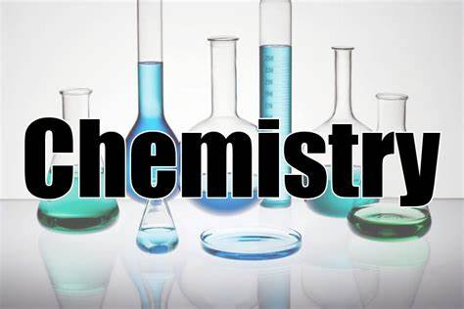
Introduction
In September you will have the opportunity to study Chemistry A level at Gateacre. It will be taught by two experienced A level teachers.
We will be teaching the AQA Chemistry A level specification (7405).

Course content
The specification builds on the Combined Science GCSE so you do not need to have done separate sciences to do the course. The topics covered in the Chemistry GCSE will probably be familiar to you from the GCSEs you are doing but will be covered in much more depth.
The course is split into 3 mains sections:
- Physical chemistry – Which includes atomic structure; bonding; energy changes and redox reactions;
- Inorganic chemistry – Which includes the periodic table; group 2 and 7 and chemical reactions;
- Organic chemistry – Which is the study of carbon compounds like, alkanes, alcohols and carboxylic acids.

Assessment
The course is assessed by 3 x 2 hour exams at the end of year 13 covering all the topics taught through the 2 years of the course.
Why do chemistry?
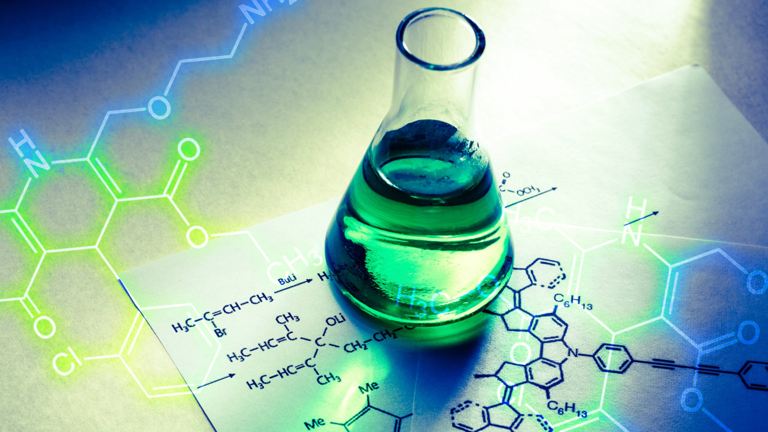
Chemistry A level is a well thought of A level by both universities and employers and it prepares you for a wide variety of careers. If you want to do medicine or other medical careers chemistry is essential but it also is needed for engineering and forensics. Chemistry is an interesting, challenging and rewarding course, it is practically based so if you enjoy practical work and problem solving Chemistry is the A level for you.

Entry Requirements – cases considered on an individual basis but Grades 55/66 and higher, including Maths, are usually a good starting point! All cases will be discussed on a case by case basis by the sixth form team.
If you have any question please contact the following staff:
- Mr Copsey - g.copsey@gateacre.org
- Mr Stopford - k.stopford@gateacre.org
- Mr Gash - d.gash@gateacre.org

