**2. Free Body Diagrams**

**1. Forces Intro**

**What do I need to be able to do?**

•Understand that forces are pushes and pulls, arising from the interaction between two objects

•Identify forces associated with deforming objects; squashing & stretching, friction between surfaces, pushing things out of the way and air/water resistance

•Describe and apply Hooke’s Law; the force-extension linear relationship

•Understand and describe non-contact forces; gravity forces acting at a distance, forces between magnets and static charges

•Understand and describe opposing forces and equilibrium; weight held by a stretched spring or supported on a compressed surface

•Calculate resultant force needed to make an object change speed and/or direction

•Use force arrows in one dimensional diagrams to show balanced and unbalanced forces

•Measure forces in newtons, and measure extension or compression of an object in m

**7.1 – Forces**

**3. Resultant Force**

All the forces acting on an object can be replaced with one **resultant force**

Forces acting in the **same direction** must be **added** together

Forces acting in **opposite directions** are **subtracted**

**Free body diagrams** model the forces acting on an object

The **arrows** show the **direction** that the force is acting in and the relative **size** of the force in comparison to the other forces on the object

Forces are **pushes** or **pulls**, arising from the **interaction** between two objects.

Forces are measured with a **newton meter** in the unit, **Newtons (N)**

**Forces can either be:**

**Contact forces –** the two objects need to be touching for the force to be exhibited

**Non-contact forces** – the force is exhibited between two objects when they are not touching

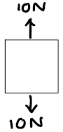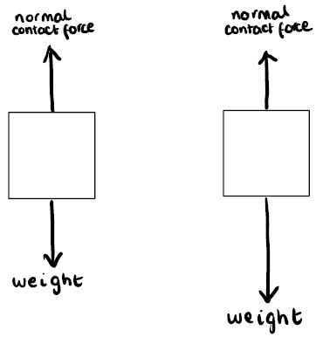

The forces in opposite directions.

10 - 10 = 0 N

No resultant force.

The forces are balanced. There is no change in speed or direction

The weight force is larger than the normal contact force. They are unbalanced. The object will move in the direction of the larger force

These forces are equal and in opposite directions. They are balanced

|  |  |
| --- | --- |
| Normal contact force | Contact |
| Tension force |
| Friction |
| Air Resistance |
| Weight | Non-contact |
| Magnetism |
| Electrostatics |

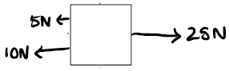

**7. Squashing and Stretching**

**6. Hooke’s Law**

**5. Drag & Friction**

**4. Weight**

The forces on the left are acting in the same direction. 5 + 10 = 15 N

They are acting in opposite directions to the force on the right. 25 – 15 = 10N resultant force

**Drag** forces occur as an object moves through **fluids** (liquids and gases), pushing **particles** out of the way. **Air and water resistance** are examples of drag forces.

Making the object more **streamlined** (less surface area in contact with the force) **decreases** the effect of drag forces

**Friction** is the force acting between two surfaces in contact with each other.

Friction **increases** with the **roughness** of the surface

Hooke’s law states that the force applied to a spring is **directly proportional** to the extension, up to a point

The graph can be used to predict the extension of a force applied, by reading from the line of best fit

The relationship can be represented by the equation:

**F = k x e**

**F** – Force (N)

**k** – spring constant (N/m) – measure of the stiffness of the spring

**e** – extension (m)

***To see worked examples of the***

***equation being used***

1. Clamp the ruler so 0 cm is level with the fiducial marker
2. **Add 100 g mass**
3. Record the extension of the spring by reading where the fiducial marker points to on the ruler
4. **Repeat adding another 100 g mass each time**

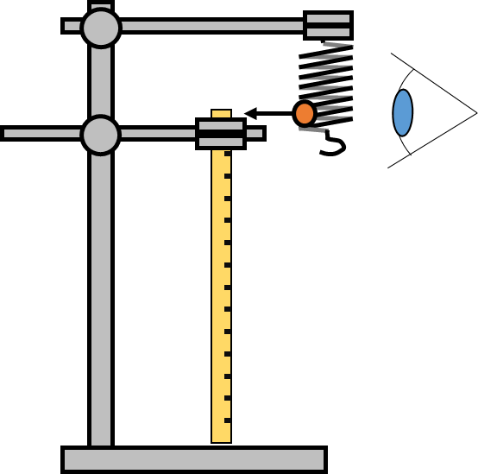

**Weight** is the force that acts on an object’s mass due to gravity. It is measured in **Newtons (N)**

**Mass** is a measure of how difficult it is to change the motion of an object. It is measured in **kilograms (kg)**

Weight can be calculated using the equation:

**W = m x g**

**W** – Weight (N)

**m** – mass (kg)

**g** – gravitational field strength (N/kg)

The gravitational field strength of the Earth is 9.81 N/kg

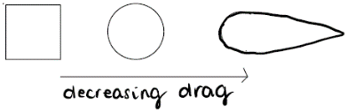

Plot a graph of **force** added (N) – 100g is roughly equal to 1N – on the **y axis** and **extension** of the spring (m) on the **x axis**

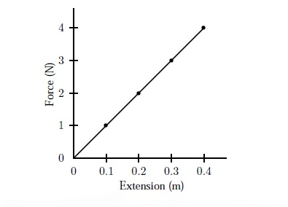



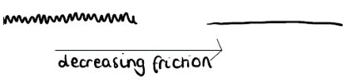

|  |  |
| --- | --- |
| **Key term** | **Definition** |
| Kilogram | A unit of mass. 1 kg = 1000 g. |
| Equilibrium | Forces in a system/acting on an object are balanced |
| Weight | The force that acts on an object’s mass due to gravity |
| Mass | A measure of how difficult it is to change the motion of an object |
| Gravitational field strength | The measurement of the gravitational force exerted per unit mass |
| Interaction | Action that occurs as two or more objects effect on one another |
| Directly proportional | When the values of the two variables are related by a constant multiplier |
| Extension | The **change** in length of an elastic object after it has been stretched |
| Normal contact force | The push force produced on objects when they push on something solid. Also called ‘reaction’ force |
| Newton meter | A spring calibrated so that it has a scale to measure force |
| Spring constant | A measure of the stiffness of the spring |
| Newton | The unit of force |
| Gravity | The force acting between any two objects, pulling them towards each other |



**Link it**

**1.** Use the particle diagrams to explain why you’d feel more resistance trying to move through water than you’d do through air.

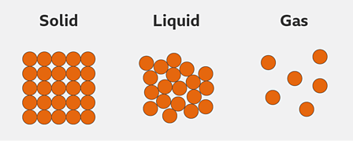

**2**. Calculate the spring constant of a spring that extends 0.25m when 4N is loaded onto it.

**3**. Calculate the extension of spring with a spring constant of 0.44 N/m when 2.6N is loaded onto it.

4. The graphs show how the extension changes with stretching force for 4 different materials

a. Which graphs show materials that obey Hooke’s Law? Explain your answer.

b. Which graphs show materials that become less stiff as they are stretched? Explain your answer.

4. A car has a weight of 24000N which is distributed equally over 4 wheels. Each wheel has a spring constant of 40 N/. Calculate the compression of each spring.

**4.** Calculate the mass of this block

***Hint – think carefully about units***

Density = 0.75 kg/m3

**Grasp it**

**Types of Forces**

1. People sometimes think that air resistance is a non-contact force. Can you explain why some people might think that?

2. Explain why magnetism is a non-contact force.

**Hooke’s Law**

3. How could the extension of a spring be calculated in the investigation if you were not using a fiducial marker?

4. Predict the extension of the spring when 4 N are added and explain your reasoning

|  |  |
| --- | --- |
| Force (N) | Extension (m) |
| 0 | 0.07 |
| 1 | 0.09 |
| 2 | 1.10 |
| 3 | 1.30 |

5. 1 spring has a spring constant of 0.38 N/m and another has a spring constant of 1.15 N/m. Describe the difference in the results of the investigation with these two springs

6. Calculate the force needed to extend a spring with a spring constant of 2.75 N/m by 0.15m

7. Calculate the force needed to extend a spring with a spring constant of 0.8 N/m by 0.3cm

**Drag and Friction**

8. Describe an investigation you could do to determine which surface generated the most friction between sandpaper, carpet and wood. Make sure to include your independent variable, your dependent variable and how you will measure it and any control variables.

9. Explain how streamlining works to reduce drag forces on an object and why it is done in industry to cars.

**Weight**

10. Calculate how much heavier a 65 kg person would be on the Earth, compared to the moon (g = 1.6 N/kg)

11. Calculate the weight of a 300g object on a planet that has a gravitational field strength, 4 x that of the Earth.

**Know it**

**Types of Forces**

1. Define the term ‘contact force’

2. Give 4 examples of contact forces

3. Define the term ‘non-contact force’

4. Give 3 examples of non-contact forces

5. What is the unit of measurement of forces?

**Free Body Diagrams**

6. Describe what a free body diagram shows

7. Draw a free body diagram to show the forces acting on a bottle on a table

8. Draw a free body diagram to show the forces acting on a football as it moves through the air, after being kicked.

**Resultant Force**

9. Calculate the resultant force in these situations and describe the motion of the object.

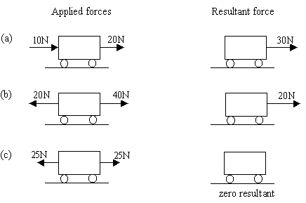

**Hooke’s Law**

10. Define the term ‘elastic’ as it relates to a material

11. Define the term ‘directly proportional’

12. Recall the equation used to calculate the force applied to extend a spring by a certain distance.

**Weight**

14. Describe the difference between weight and mass.

15. State the units of weight and mass

16. Calculate the weight of a 50 kg person on the Earth.

17. Why does your weight decrease on the moon?