The male gamete – sperm cell. Produced in the testes.
1. Adolescence
2. Reproductive Systems
7.10 – Reproduction
3. Fertilisation & Implantation

What do I need to be able to do?
•Describe the reproduction in plants, including flower structure, wind and insect pollination, fertilisation, seed and fruit formation and dispersal, including quantitative investigation of some dispersal mechanisms.

•Understand the importance of plant reproduction through insect pollination in human food security

•Describe reproduction in humans (as an example of a mammal), including the structure and function of the male and female reproductive systems, menstrual cycle, gametes, fertilisation, gestation and birth, to include the effect of maternal lifestyle on the foetus through the placenta
Male
Penis – fills with blood and stiffens (erection) and allows the male to release sperm inside the vagina Sperm duct – carries sperm from the tests to the penis.

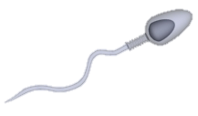
Nucleus – contains ½ father’s DNA
Tail – helps it move to the egg
Cytoplasm contains lots of mitochondria to allow for maximum respiration to release energy for the sperm to move.

Happens between the ages of 9 and 14 in most people

Puberty – the physical changes that occur
Adolescence - the physical and emotional changes

The purpose of the changes are to prepare our bodies to reproduce.
The changes are caused by hormones

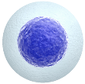
Nucleus – contains ½ mother’s DNA

The egg cell is around 20 x larger than the sperm cell
The female gamete – egg cell. Produced in the ovaries.
Gland – produces a nutrient fluid that keeps the sperm alive. The mixture of this fluid and sperm is called semen
Testes – produce the male gamete; sperm cells and the male sex hormone; testosterone
Scrotum – a bag of skin that holds the testes slightly outside of the body, at a lower temperature that is better for the sperm.

Female
Oviduct – tube connects the ovary to the uterus. Fertilisation occurs here.

Girls | Boys
Breasts develop | Testes & penis get bigger
Hips widen | Shoulders widen
Hair grows on legs and underarms | Hair grows on face, chest, legs and underarms
Pubic hair grows
Ovaries produce the hormone oestrogen | Testes produce the hormone testosterone
Becomes attracted to someone else
Become more concerned about appearance
Might become more aggressive/emotional
Ovaries start to release egg cells | Testes start to produce sperm cells
Get taller
Periods start | Voice breaks

Fertilisation
During fertilisation, the nucleus of the sperm and the egg cell fuse together. The fertilised egg cell contains DNA from both parents.

Fertilisation occurs in the oviduct.

The cilia lining the walls of the oviduct ‘waft’ the fertilised egg cell towards the uterus

The cell implants itself into the lining of the uterus where it divides to form a ball of cells called an embryo

5. Pollination
6. Menstrual Cycle
7. Development of a Foetus
Ovary – contains egg cells. Produces the female sex hormone oestrogen
Uterus – where the foetus develops
Cervix – a ring of muscle that holds the foetus in place during pregnancy
4. Seed Dispersal
Seeds are spread far away from each other and the parent plant. This is called seed dispersal.
This is so they have space to grow and they are not in competition for resources.

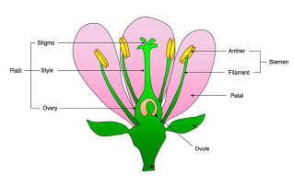
The menstrual cycle prepares the uterus to receive a fertilised egg cell.
Each cycle lasts 28 days.
The cells in the embryo continue to divide and specialise, forming a foetus
Gestation – the duration of time that the woman is pregnant for. Usually 40 weeks in humans

Day | Event
1-5 | The period – menstruation  - The blood rich lining of the uterus is lost from the body through the vagina
5-13 | •Walls of the uterus start to thicken and become filled with blood, ready for implantation of a fertilised egg cell  •An egg matures ready for fertilisation in the ovary
14 | Ovulation  An egg is released from an ovary
14-16 | The egg moves down the oviduct ready to possibly be fertilised
22-28 | If the egg cell is not fertilised by day 21, the lining of the uterus breaks down ready to be shed at day 1 of the next cycle
Method of seed dispersal | Description
Animals: internally | Seeds or fruit with seeds in are eaten, transported and excreted out in a different location
Animals: externally | Seeds get stuck to animals fur, are transported and then will drop off in a different location
wind | Blown by the wind to a different location
Water | Float on water and germinate when reach the land
Explosion | Pods carrying seeds ‘pop’ or fall to the ground and break open, scattering seeds

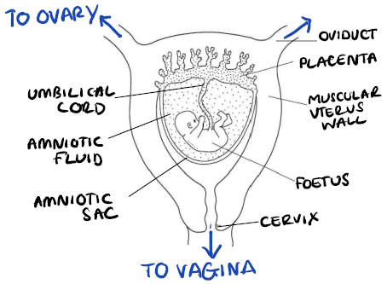

Pollen (male gamete) needs to transfer from the anther to the stigma so it can travel down and fertilise the ovule (female gamete). This is called pollination
There are two ways that the pollen of a plant can reach
the stigma of another; wind and insects

insect pollinated plants have brightly coloured petals and sweet tasting nectar to attract insects. The pollen sticks to the insect and is transported to another plant.

wind pollinated plants have low mass, large surface area pollen so they can travel further in the wind and increase the chance of landing on a stigma of another flower

The placenta is the organ in which the blood of the foetus and the mother flows very close together. Here substances like O₂, glucose and antibodies can diffuse from the mother’s blood into the foetus’ and waste products such as CO₂ and urea can diffuse in the opposite direction for excretion

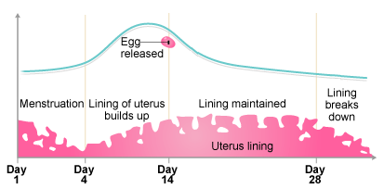
Seeds look different and have different features dependent on their dispersal method e.g. seeds that are dispersed by animals, externally – have prongs and hooks to attach to animal’s fur

Key term | Definition
Gamete | A sex cell
Hormone | A chemical messenger that is transported in the blood stream
Excreted | Elimination of waste matter
Fertilisation | The nucleus of the male and female gamete (sperm and egg or pollen and ovule) fuse together - combining the DNA of both organisms.
Germinate | The growth of a plant from a seed
Gestation | The period of the development of a foetus
Diffuse | Movement of particles from an area of high concentration to an area of low concentration
Foetus | Stage in between foetus and baby.
Respiration | A chemical reaction to transfer energy from the chemical energy store in glucose by reacting it with oxygen
DNA | A chemical that carries genetic information
Embryo | A ball of undifferentiated cells
Pollination | Fertilisation of an ovule by a pollen cell
Dispersed | Spread out far from original location
Implantation | The fertilised egg cell buries itself into the wall of the uterus
Cilia | Hair like projections from cells that sweep in unison
Link it

1. Explain how smoking and drinking whilst pregnant can cause harm to the baby.

2. Which seed will travel furthest in the wind? Explain your answer, referring to forces

3. Explain why periods stop whilst you are pregnant.

4. Compare the similarities and differences between fertilisation in humans and pollination in plants

5. Explain what is occurring when the ‘waters break’ during early stages of labour.

6. When a pregnant woman is in labour, she experiences contractions – what is happening at this point?

7. Explain how identical and non-identical twins are formed.

8. 100 million sperm are released in every ejaculation. Considering only one sperm cell can fertilise the egg cell, why are so many released?

9. Females are born with all of the egg cells she’ll need stored in her ovaries. If she begins puberty at 11 and goes through menopause at the age of 53 – how many eggs has she released in her lifetime?

10. Why do you think women have 2 ovaries, when only 1 egg is released from an ovary each month?

11. Research how in vitro fertilisation is performed and why.
Grasp it

Adolescence & Puberty
1. Why do female’s breasts develop during puberty?
2. Why do females’ hips widen during puberty?
3. Which hormone causes the changes that occur in males?
4. Which hormone causes the changes that occur in females
5. Describe where these hormones are made.

Reproductive Systems
6. Why do sperm cells contain lots of mitochondria?
7. Why does the uterus have thick muscular walls?
8. Why are the testes held slightly outside of the body in the scrotum?

Fertilisation & Implantation
9. What would happen if a woman had one oviduct blocked?
10. Why do the gametes only contain half the DNA of the parent that it came from?
11. Explain how condoms work to prevent pregnancy.

The Menstrual Cycle
12. On which day of the cycle is the highest chance of getting pregnant?
13. What happens to the egg cell after it has been released, if it is not fertilised?
14. Why does the lining of the uterus wall build back up between days 5 and 13.?

Pollination
15. What is the difference between self and cross pollination?
16. How are plants adapted for inset pollination
17. Explain the impact that reducing numbers of bees will have on the growth of crops to eat.

Seed Dispersal
18. describe the adaptations that a seed that is dispersed by animals internally has,

Know it

Adolescence & Puberty
1. Between what ages so most people start puberty?
2. Describe the difference between puberty and adolescence.
3. Give 2 changes that only occur in females
4. Give 2 changes that only occur in males
5. Give 2 changes that occur in both males and females

Reproductive Systems
6. Name the tube that connects the ovary and the uterus
7. What is the function of the cervix?
8. What is ‘semen’?
9. Define the term ‘gamete’
10. Where are the male and female gametes produced?

Fertilisation & Implantation
11. What happens to the sperm and egg cell during fertilisation?
12. Where does fertilisation occur?
13. How does the egg cell reach the uterus?

The Menstrual Cycle
14. How long does the cycle last?
15. Why is it described as a cycle?
16. What happens on day 14?
17. How long does the period last?
18. What happens during the period?

Pollination
19. Name the male gamete of the plant
20. Name the female gamete of the plant
21. On what part of the plant is the male gamete held?

Seed Dispersal
22. Why does the plant want to disperse its seeds far from itself and from other seeds?
23. Describe how animals can help the dispersal of seeds for plants.
24. A coconut is a hollow seed. What type of seed dispersal is it best adapted for?

