2. The Solar System
1. The Night Sky
8.1 – Space
What do I need to be able to do?
•Describe; gravity force as different on other planets and stars; gravity forces between Earth and Moon, and between Earth and Sun
•Identify; our Sun as a star, other stars in our galaxy, other galaxies
•Describe; the seasons and the Earth’s tilt, day length at different times of year, in different hemispheres
•Understand the light year as a unit of astronomical distance.
•Calculate weight = mass x gravitational field strength (g), on Earth g=10 N/kg
•Scale models of distances between celestial bodies and sizes
•Modelling orbits and spin of celestial bodies
•Modelling; day night/seasons/temperature differences and phases of the moon with light source

3. The Earth
Hemisphere – half a sphere (northern and southern)
A day - time taken for the Earth to spin on its axis once (24 hours)
A year - the time taken for the Earth to complete 1 orbit around the sun (365.25 days)
Tilt - the angle of rotation measured from perpendicular to the solar plane (23.5° for Earth).

Seasons:

Our Solar System contains:
A Star: The Sun
Planets: Which go around the Sun
Satellites: Which go around planets
Smaller objects: Such as asteroids and comets
An orbit is a regular, repeating path that one object in space takes around another one.

These can be
circular or
elliptical
depending on
the object and
the circumstances
around its
formation.

Smaller than some moons!

Hottest! (450°C)

Home!

6 rovers on here!

Largest!

Less dense than water!

Spins on its side! (98° tilt)

Coldest! (-200°C)

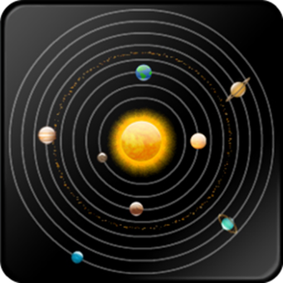

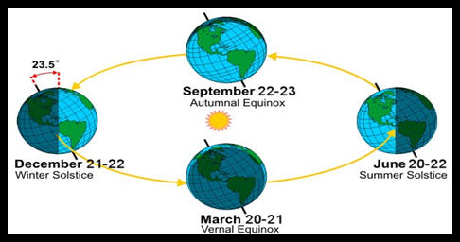

5. Gravitational Field Strength
6. The Universe
4. The Moon
Galaxy - a large group of gravitationally bound stars. (Can number trillions!)
The Universe - everything in existence.

The Big Bang - an energetic event that occurred at the start of our Universes existence,
Black hole - the final stage of the life of the largest stars. Its gravity is so strong nothing can escape it.
Nebula - huge clouds of gas in which stars are formed.

Seasons:

The Moon is a natural satellite of the Earth.

The Moon completes 1 orbit of the Earth every 28 days.

Its position relative to the Earth and the Sun causes it to appear different in the night sky as the amount of observed reflected light changes.

It doesn’t matter where in the Universe you are, your mass will not change.
Your weight is dependent of the size of the gravitational field strength.
So, because “g” is around 6 times less on the Moon than it is on Earth, you would weigh around 6 times less on the Moon!
We can use the following equation to calculate the weight of an object on a planet (e.g. Earth):
Weight = mass x gravitational field strength
(N) (kg) (N/kg)
E - W = m x g
V - m = 65 kg g = 10 N/kg
E - W = 65 x 10
R - W = 650
Y - W = 650 N/kg

Weight is a force that is dependent
on the amount of gravity an object feels.
Mass is a measure of how difficult it is to change the motion of an object.

Gravity (gravitational field strength)
is the force acting on each kilogram of mass.

On Earth the gravitational field strength (g) is approximately 10 N/kg.

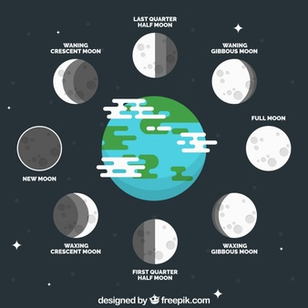

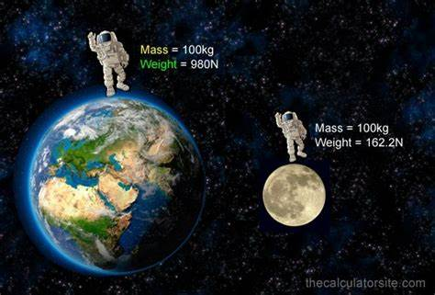
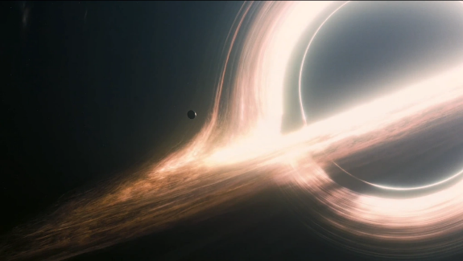

Key term | Definition
Galaxy | A large group of gravitationally bound stars. (Can number trillions!)
The Universe | Everything in existence.
Black hole | The final stage of the life of the largest stars. Its gravity is so strong nothing can escape it.
Luminous | Emitting light.
Nebula | Huge clouds of gas in which stars are formed.
Weight | Is a force that is dependent  on the amount of gravity an object feels.
Mass | Is a measure of how difficult it is to change the motion of an object.
Gravity | Is the force acting on each kilogram of mass.
Star | A large sphere of hot plasma.
Planet | A spherical object that orbits a star.
Moon | A natural satellite of a planet.
Tilt | The angle of rotation measured from perpendicular to the solar plane (23.5° for Earth).
1 year | The time taken for the Earth to complete 1 orbit around the sun (365.25 days)
1 day | The time taken for the Earth to spin on its axis once (24 hours)
Reflected | Waves hitting and then bouncing off a surface.
Orbit | The path an object takes around another that it is gravitationally bound to.
EVERY Method

Use the EVERY method to complete the following calculations.

1. Calculate the missing values:

Planet | g (N/kg) | Mass | Weight
Mercury |  | 70 kg | 252 N
Venus | 8.83 |  | 618.7 N
Jupiter |  | 75000 g | 1950 N
Saturn | 11.2 | 42175 g
Neptune | 13.3 |  | 0.958 kN

2.
a. What would happen to your weight if you went from the Earth to the Moon?
b. What would happen to your mass if you went from the Earth to the Moon?

3.
a. What would the weight of a 200 g apple be, if it was dropped from the top of a ladder on the Moon (g=1.6 N/kg)?
b. Draw a free body diagram for the apple when it is held before it is dropped
c. Draw a free body diagram for the apple just after it is dropped

4.
a. What would be the difference in a person's weight on Mars (g = 3.75 N/kg) be compared to on Earth (g = 9.81 N/kg) if they have a mass of 65kg?
Give your answer in kN.
b. Is weight a contact or a non-contact force? How do you know?

5.
What is the weight of a 500 g object on a planet with a gravitational field strength, 2.5 times that of the Earth?
Grasp it

Our Solar System
1. Draw a diagram to show the differences in orbits between a planet and a comet.
2. Explain why Jupiter “years” are longer than a year on Earth.
3. Our sun is luminous. Explain what this means.
4. Is our Moon luminous? Explain your answer.

The Moon
5. Our Moon can sometimes be seen during the night. Explain why
6. Describe how a full moon occurs.
7. Describe how a new moon occurs.

Seasons
8. Explain why a day in the northern hemisphere is shorter during the winter.
9. Explain why a day in the northern hemisphere is 12h long at around March 21st each year.

Know it

Planets
1. What are planets?
2. What is an orbit?
3. Define the term tilt.
4. How many planets are in our solar system?
5. which planet is the largest?

Satellites
6. What is the difference between a ‘natural’ and a ‘man-made’ satellite?
7. How long does it take for our moon to orbit the Earth?

Gravitational Field Strength (g)
8. How strong is the gravitational field strength on Earth?
9. Which planet has the strongest value of g?
10. How does g affect your weight?

Calculating weight
11. State the equation that links weight, mass and gravitational field strength.
12. What happens to your mass when you are on the moon?
13. What is the correct unit of measurement for mass?
14. What is the correct unit of measurement for weight?
15. What is the correct unit of measurement for gravitational field strength?

The Universe
16. What is the Universe?
17. What is a galaxy?
18. What is the name of our galaxy?
19. What happens to our Universe over time?
20. How do we believe did our Universe began?

