A solution is formed when a solute is dissolved in a solvent.
e.g. when sugar is dissolved in water, sugar is the solute, the water is the solvent and the sugary water is the solution

Dissolving particles of the solute do not disappear – they just fit between the particles in the solvent.

If 10g of sugar is added to 100g of water – then you’d have 110g of sugary water solution.

The mass of solute that dissolves in 100g of water to make a saturated solution is called its solubility. This is different for every substance.
The solubility of most substances increases as the temperature of the solvent does.

2. Mixtures
What do I need to be able to do?
•The concept of a pure substances
•Mixtures, including dissolving
•Simple techniques for separating mixtures: filtration, evaporation, distillation and chromatography
•Select most appropriate technique to separate a mixture and perform it
•Identify pure substances and mixtures
•Plan investigations, identify and control variables
•Make observations and take measurements
•Make predictions and draw conclusions
•Attraction and repulsion of magnets
•The conservation of mass during dissolving
•Reversible nature of physical changes e.g. crystallisation
•Separation of coloured substances using chromatography
•Sugar/salt water not being separated by filtering

8.4 – Separation Techniques
3. Solubility & Solutions
1. Purity of a Substance
A mixture is a substance that contains 2 or more different elements or compounds, that are not chemically bonded to each other

How are compounds and mixtures different?
Mixture | Compound
Different substances are not bonded together | Atoms of different elements are bonded together
The substances in the mixture keep their own properties | The properties of the compound are different to the properties of the elements it is made of
Easy to separate | Chemical reactions are needed to separate the elements
Amounts of each substance in the mixture can vary | Number of atoms of each element in the compound is fixed

A pure substance – in Chemistry – is a singular element or compound.
e.g. bottled water is not pure as it does not only contain H₂O molecules, it also contains ions.

To identify a pure substance, it’s melting, or boiling point is measured.

sharp melting point = pure substance
dissolved

undissolved

Not a sharp melting point = impure substance

5. Evaporation and Crystallisation
6. Distillation
7. Chromatography
4. Filtration
Paper Chromatography is used to separate mixtures of soluble substances. These are often coloured substances such as inks or food colourings.
The substances are separated based on their solubilities.
The more soluble substances in the mixture move further up the chromatography paper in the solvent.

Distillation separates a solvent from a solution.
The solvent has a much lower boiling point than the dissolved solute.
- As the mixture is being heated, the solvent evaporates first, at a much lower temperature.
- The vapours then enter the condenser where they are cooled and turn into a liquid.
- The liquid collects in the beaker.
Filtration can separate an insoluble solid from a liquid. e.g. sand and water

Crystallisation can separate a soluble solid from a liquid e.g. salt and water.

The mixture is poured into an evaporating dish and heated until most of the water has evaporated.

The evaporating dish is then left to cool, and crystals form.

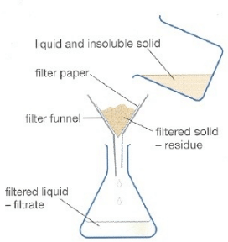

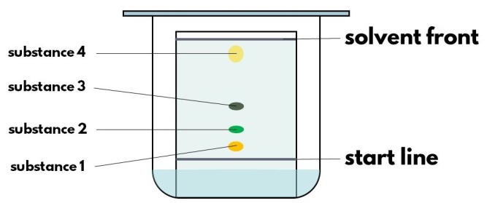
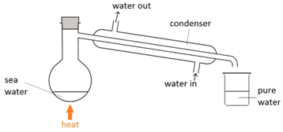

Scan here to see this being performed

The particles of the insoluble solid are too big to fit through the tiny holes in the filter paper, whereas the particles of the liquid are not.

Scan here to see this being performed
Scan here to see this being performed
Scan here to see this being performed
Key term | Definition
Pure | A substance containing only one element or compound
Melting point | The temperature at which a substance turns from the solid state into the liquid state
Boiling point | The temperature at which a substance turns from the liquid state into the gaseous state
Solute | A solid substance that dissolves in a solvent
Solvent | A liquid that a solute will dissolve in
Solution | The mixture formed when a solute dissolves in a solvent
Solubility | The mass of a substance that will dissolve in 100g of water
Saturated solution | When no more solute will dissolve in the solvent
Filtrate | The liquid that passes through the filter paper
Residue | The insoluble solid that is left on the filter paper
Soluble | A substance that can dissolve in a solvent
Insoluble | A substance that cannot dissolve in a substance
Condensation | The change of state from a gas to a liquid.
Element | Substance in which all atoms are the same type – contain the same number of protons
Compound | Substance in which atoms of different elements are bonded together
Mixture | Substance in which 2 or more different elements or compounds are not bonded together
Link it

1. Describe how you could separate the following mixtures. Include any equipment that you would need.

Mixture A – iron and sulfur
Mixture B – sand and water
Mixture C – sugar and dried peas

2. Laura has 3 beakers. Each contains 200 cm³ of a colourless liquid. Describe how Laura could find our which beakers contain pure water, and which contain solutions. Explain your answer.

3. Describe and compare the trends in solubility of sodium chloride (NaCl) and potassium nitrate (KNO₃) as the temperature is increased.
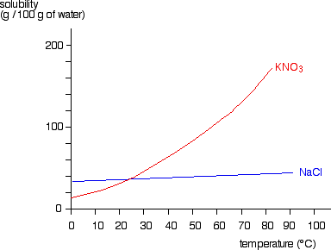
4.Rock salt is a mixture of sand and salt. Salt dissolves in water. Sand does not dissolve in water. Some students separated rock salt.
This is the method used.
1. Place the rock salt in a beaker.
2. Add 100 cm³ of cold water.
3.Allow sand to settle at bottom of beaker.
4.Pour the salty water into an evaporating dish.
5.Heat the contents of the evaporating dish with a Bunsen burner until salt crystals start to form.
(a) Suggest one improvement to step 2 to make sure all the salt is dissolved in the water.
(b) The salty water in step 4 still contained very small grains of sand. Suggest one improvement to remove all the sand.

Grasp it

Purity of a Substance
1. Time heats a substance. He plots the temperature every minute. Use the graph to decide whether the substance is a pure or a mixture. Explain your decision.

Mixtures
2. Describe the composition of each of these mixtures from their particle diagrams

Solubility & Solutions
3. Define the term ‘saturated solution’
4. Define the term ‘solubility’
5. At 50°C, the solubility of sugar in water is 130g – describe what this means
6. If 17g of sugar dissolves in 50g of water – what will be the mass of the solution formed?

Filtration
7. Describe how the filter paper separates the insoluble solid from the liquid.
8. Why can’t filtration be used to separate a mixture of salt and water?

Distillation
9. Describe the changes of state that occur, and where, during distillation
10. Explain how distillation can be used to separate a mixture of substances with different boiling points?

Chromatography
11. Which property of the substances in the mixture does chromatography separate based on?
Know it

Purity of a Substance
1. Define the term ‘pure substance’
2. How do you test for the purity of a substance?
3. Describe the boiling point of a pure substance
4. Describe the boiling points of a mixture

Mixtures
5. Define the term ‘mixture’
6. Define the term ‘compound’
7. Draw a particle diagram to represent a mixture
8. Draw a particle diagram to represent a compound

Solubility & Solutions
9. Define the term ‘solute’
10. Define the term ‘solvent’
11. Define the term ‘solution’
12. Define the term ‘soluble’
13. Define the term ‘insoluble’

Filtration
14. A mixture, containing what type of substance can filtration separate?
15. Give an example of a mixture that can be separated by filtration
16. Define the term ‘filtrate’
17. Define the term ‘residue’

Evaporation & Crystallisation
18. A mixture, containing what type of substance can evaporation and crystallisation separate?
19. Give an example of a mixture that can be separated by evaporation and crystallisation

Distillation
20. A mixture, containing what type of substance can distillation separate?
21. Give an example of a mixture that can be separated by distillation

