8.5 – Light Waves
Diffuse scattering – occurs when light reflects off of rough surfaces. No image is formed because most of the reflected light does not reach your eye e.g painted walls, paper.

Specular reflection – occurs when light reflects off smooth surfaces. A clear image is formed because all light reaches your eye e.g still water, mirrors, metals.

Light travels as waves. All waves are oscillations (vibrations) that transfer energy.
Light waves are oscillations in the electric and magnetic fields around the Earth.
More on this in 8.8 – Electromagnetism

Light waves are transverse – the oscillations are perpendicular to the direction of energy transfer. They do not need a substance to travel through.
See 7.8 Sound Waves for a recap on types of waves

Peak | Highest point of a wave
Trough | Lowest point of a wave
Amplitude | Distance from the still position to the maximum disturbed position
Wavelength | Distance between the same point on two consecutive waves
Frequency | Number of waves passing a point per second. Measured in hertz (Hz)

2. How do we see objects?
1. The Nature of Light Waves
What do I need to be able to do?
•Compare the similarities and differences between light waves and waves in matter
•Describe; light waves travelling through a vacuum; speed of light
•Describe the transmission of light through materials: absorption, diffuse scattering and specular reflection at a surface
•Use of ray model to explain imaging in mirrors, the pinhole camera, the refraction of light and action of convex lens in focusing in the human eye
•Light transferring energy from source to absorber leading to chemical and electrical effects; photo-sensitive material in the retina and in cameras
•Describe; colours and the different frequencies of light, white light and prisms (qualitative only); differential colour effects in absorption and diffuse reflection.
•Construct ray diagrams to show; how we see luminous and non-luminous objects, the laws of reflection/ refraction
•Link frequency and wavelength to colour of visible light
•use s=d/t equation to calculate speed of a wave

3. Reflection
Light waves travel in straight lines, so when we are drawing ray diagrams, we must use a ruler.

Luminous objects – emit light e.g. The Sun, a lightbulb

Light travels directly from the light source to your eye

Non-luminous objects – do not emit light, but reflect the light of other objects e.g. The Moon, a book

Light reflects off of the object and is absorbed by the eye

Transverse waves, such as light, do not need a substance to travel through, therefore can travel through a vacuum. This is how light from the Sun travels across space.

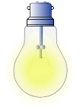
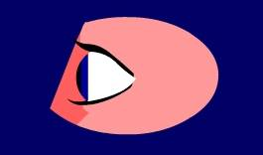
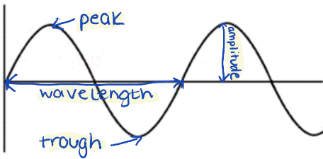

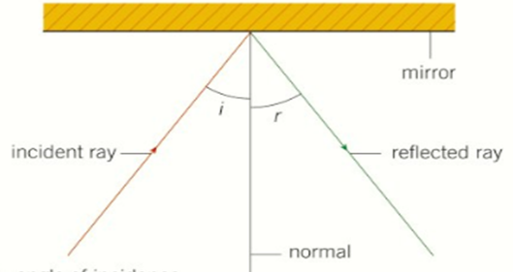
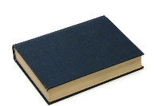

Law of reflection
Angle of incidence (i) = angle of reflection (r)

7. Speed of Light
5. The Eye
4. Refraction
6. Colour
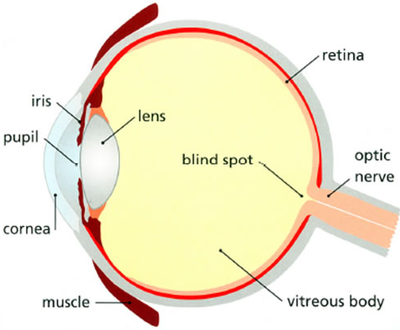
Light travels extremely quickly. Its maximum speed is approximately 300,000,000 m/s, (or 300,000 km/s) when it travels through a vacuum such as space. This is approximately a million times faster than the speed of sound.
It takes 8 minutes and 20 seconds for light from the Sun to reach the Earth.

We can use the following equation to calculate the distance from the Sun to the Earth:
Speed (km/s) = distance (km) ÷ time (s)
E - s = d ÷ t
V - s = 300,000 km t = 8 mins 20 s = 500 s
E - 300,000 = d ÷ 500
d = 300,000 x 500
R - d = 150,000,000
Y - d = 150,000,000 km

Iris | A ring of muscle that contracts/relaxes to change the size of the pupil to control how much light enters the eye.
Pupil | A hole that allows light to hit receptor cells on the retina
Cornea | Refracts light as it enters the eye
Lens | Refracts and focusses light onto the retina to create an image. It can change shape to bend light more or less.
Retina | Contains the light receptor cells
Optic nerve | Carries electrical impulses from the eye to the brain

White light is a mixture of all colours. A prism can be used to separate white light into its colour spectrum.
The different colours have different wavelengths and frequencies and so each is refracted to a different degree – separating the colours.

When light leaves a less dense material, such as air, and enters a denser material such as water or plastic, it slows down. The change in speed also causes it to change direction.
This is refraction.

As the light enters a more dense material it bends towards the normal.
As the light enters a less dense material, it bends away from the normal
The two rays outside of the glass block are parallel. Angle of incidence = emergent angle

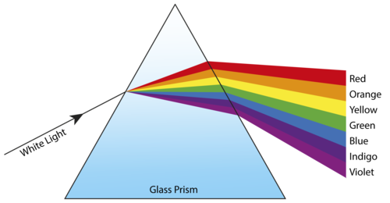
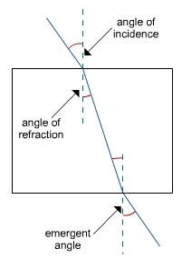
normal

glass
air

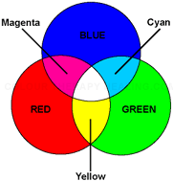
White lights is made up of 3 primary colours; red, green and blue.
Two primary colours mixed together gives a secondary colour.
Red, green and blue light mixes together to make white light

Objects appear a certain colour due to the wavelengths of light they reflect e.g. a red book appears red because it reflects red wavelengths and absorbs all others
Key term | Definition
Oscillations | Regular vibrations
Transverse | Oscillations occur perpendicular to the direction of energy transfer
Perpendicular | At right angles (90°) to
Luminous | Emitting light
Vacuum | A space containing no particles
Reflection | When a light wave hits a material and bounces off
Refraction | When a light wave enters a medium of different density, changes speed and direction
Density | Mass per unit of volume
The normal | A line on a ray diagram running perpendicular to the boundary of a material
Angle of incidence | The angle between the incidence ray and the normal
Angle of reflection | The angle between the reflected ray and the normal
Angle of refraction | The angle between the refracted ray and the normal
Emergent angle | The angle between the emergent ray and the normal
Spectrum | A range of wavelengths
Frequency | Number of waves passing a point every second
Wavelength | Distance between the same point on two consecutive waves
Lens | A piece of transparent material with curved sides that refracts light waves
Grasp it

Nature of light Waves
1. Draw two waves: same amplitude but different frequencies
2. Draw two waves; same frequency but different amplitudes
3. Draw two waves, one with double the wavelength of the other
4. Describe the relationship between the wavelength and frequency of a wave.

How do we see objects?
5. Naomi kicks a ball in her garden. Explain how the ball is visible to Naomi.
6. Draw a ray diagram to represent your answer to Q6.
7. Add arrows to the diagram below to show how the light waves when George is using his laptop.
Reflection
8. Explain why you cannot see your reflection on a brick wall.
9. If the angle of incidence is 37°, what will be the angle of reflection? Explain your answer.

Refraction
10. Why does a light wave bend more towards the normal when it enters a denser material?
11. Which diagrams shows correct rays?
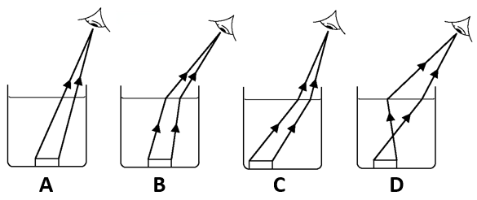
Colour
12. Explain why a blue box appears blue.
13. Explain why a yellow box appears yellow.
14. What colour would a red box appear when looking through a green filter? Explain your answer

Know it

Nature of Light Waves
1. What are light waves?
2. What do light waves transfer?
3. Define the term amplitude.
4. Define the term frequency.
5. Define the term wavelength.

How do we see objects?
6. Is a mirror a luminous or a non-luminous object? Explain your answer
7. Is a candle a luminous or a non-luminous object? Explain your answer

Reflection
8. Describe specular reflection.
9. Describe diffuse scattering reflection.
10. State the law of reflection

Refraction
11. Define the term refraction
12. Define the term density
13. Describe how a light wave bends when it enters a more dense material
14. Describe how a light wave bends when it enters a less dense material
15. State the law of refraction

The Eye
16. What is the function of the iris?
17. What is the function of the pupil?
18. What is the function of the cornea?
19. What is the function of the lens?
20. What is the function of the retina?
21. What is the function of the optic nerve?

Colour
22. State the 3 primary colours.
23. What secondary colours are formed when the following primary colours are mixed:
a. blue and green
b. blue and red
c. red and green

Link it

1. When will a light wave not refract through a Perspex block? Explain why.

2. Use the law of reflection to help you fill in the missing angles.

3. Use the particle model to explain why a light wave will refract more when entering a glass block from air, than entering argon from air (a gas denser than air).

4. Use your knowledge of colour to explain why chlorophyll is green. Link it to the function of chlorophyll.

5.a. The speed of sound is about a millionth of the speed of light. Calculate the speed of sound.
b. It takes light reflected from the Moon,1.3 seconds to reach the Earth. Calculate the distance from the Moon to the Earth in km.
c. It takes light from the Sun 43 minutes to reach Jupiter. Calculate the distance from the Sun to Jupiter in km.

6. The optic nerve is nervous tissue made of lots of nerve cells working together. Describe the adaptations of a nerve cell to perform its function.

7. Short sightedness can be caused by the cornea being too curved. Explain how this can result in a blurry image being formed when looking at distant objects.

