2. Adaptations
What do I need to be able to do?
•Understand inheritance as the process by which genetic information is transmitted from one generation to the next
•Describe a simple model of chromosomes, genes and DNA in inheritance, including the part played by Watson, Crick, Wilkins and Franklin in the development of the DNA model
•Describe differences between species
•Describe the variation between individuals of the same species being continuous or discontinuous
•Understand the variation between species and between individuals of the same species means some organisms compete more successfully, which can drive natural selection
•Understand that changes in environment may leave individuals within a species, and some entire species, less well adapted to compete successfully and reproduce, which may lead to extinction
•Understand the importance of maintaining biodiversity and the use of gene banks to preserve hereditary material.
•Produce measurements and graphical representation of continuous or discontinuous variation
8.6 – Adaptations & Inheritance
Animals need to be the best competitors for resources to make sure they survive.

Some animals have good eyesight or hearing which make it easier to spot their prey.

The features that enable an organism to compete better for resources than other organisms are called adaptations

1. Competition
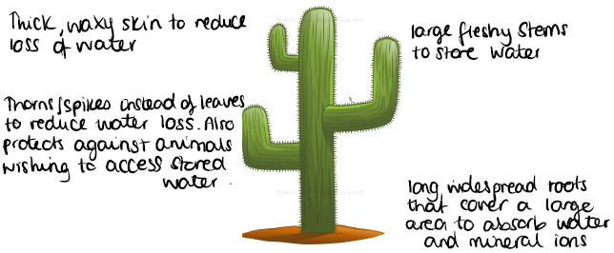
In a habitat there is a limited supply of resources. To survive, animals compete to get enough of these resources.

Animals compete for:
- Food
- Water
- Space/territory
- Mates – to reproduce

Plants compete for:
- Light
- Water
- Mineral ions
- Space

Remember – plants do not compete for food because they make their own glucose via photosynthesis.

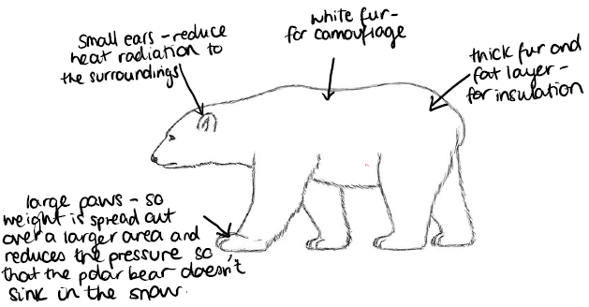

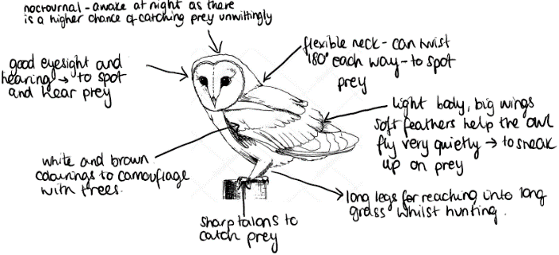

3. Variation: Inherited & Environmental
4. Inheritance
5. Natural Selection
6. Extinction
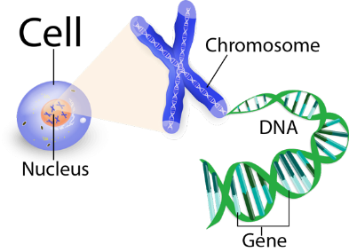
Species become extinct when there are no longer any living individuals of that species.
Factors that lead to extinction:
•Change to their environment e.g. lack of resources
•Destruction of habitat
•Outbreak of a new disease
•Increased predation
•Increased competition

Scientists are trying to prevent endangered species from becoming extinct and also maintain biodiversity
One way is by using gene banks. Samples of the endangered species (e.g. plant cuttings and sex cells of animals) are stored so that their DNA can be used in the future to create new individuals

Scientists have shown that the species we see on Earth today have gradually changed over millions of years. This is called evolution. The fossil records provides evidence of species that are extinct e.g. dinosaurs

Organisms evolve through a process called natural selection
•Organisms within a species show variation – this is due to differences in their genes.
•Some organisms with characteristics that make them better adapted to their environment survive more and the less adapted organisms die. This is survival of the fittest
•The organisms that are better adapted reproduce and pass on their genes for the adaptations to their offspring.
•The offspring now also show these characteristics that make them better adapted
•This process is repeated many times. The species changes so much that a new species if formed. This is evolution

The genetic information for each organism is stored as a chemical, DNA, in the nucleus of cells. The DNA is tightly wound into chromosomes.
Each section of DNA is a gene.

Variation is the difference in characteristics. There is lots of variation between organisms of the same species. e.g. humans have different heights, eye colour, hair colour, blood group etc

Variation can either be:
Inherited – a result of genes inherited from parents e.g. natural hair colour, eye colour, blood group, presence of dimples

Environmental – as a result of differences in surroundings, or choices that the individual makes. e.g. scars, tattoos, language spoken, accent
This accounts for the differences observed in identical (genetically) twins.

Or…as a result of both inherited and environmental factors
e.g. height – you inherit genes for your height from your parents, but it is also largely influences by your diet.
Similarly, with weight, intelligence etc

Different genes control the development of different characteristics by issuing instructions to the cell.
.

One gene contains the instructions for making one protein. Several genes work together to form a single characteristic, e.g. eye colour.

Egg and sperm cells are the only cells to contain 23 chromosomes. They only have one copy of each chromosome. During fertilisation, the nuclei of the egg and sperm cells fuse together. The chromosomes pair up producing an embryo with cells containing 46 chromosomes (23 pairs)

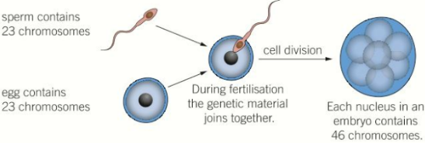

Key term | Definition
Habitat | The place where an organism lives
Radiation | Transfer of energy from thermal stores by electromagnetic waves
Adaptations | Features that make an organism better able to compete for resources
Photosynthesis | The chemical reaction that occurs in chloroplasts of plant cells where energy from the sun is used to react water and carbon dioxide together to produce glucose and oxygen
Variation | Differences between organisms
Inheritance | DNA being passes from parents to offspring via sperm and egg cells.
DNA | A chemical that carries genetic information and contains instructions for the organism
Chromosome | Strands of DNA tightly wound
Gene | A section of DNA that codes for the production of a protein. A characteristic is coded for by a combination of genes
Fertilisation | When the nucleus of a sperm cell fuses with the nucleus of an egg cell – to produce a cell with 46 chromosomes (23 from the mother and 23 from the father)
Evolution | The process by which species change over many generations, due to natural selection.
Extinction | No living individuals of a species
Biodiversity | The number of different species of living organisms
Gene banks | DNA of organisms are stored in case of the extinction of their species.
Offspring | A person’s child/children or an animal’s young
Link it

1. Design a super predator – label all the adaptations and describe any changes to its behaviour it makes to adapt to environmental changes throughout the year

2. Scientists investigated how the leg length of the Anolis lizards affected their survival. At the start of the investigation the Anolis lizards had a large range of leg lengths.

•The scientists placed six Curly-tailed lizards onto the island.
•The Curly-tail lizard is a predator of the Anolis lizard.
• After one year the population of Anolis lizards had halved.
•Nearly all the remaining Anolis lizards had long legs.

(a) Why did the population of Anolis lizards halve?

(b) The remaining Anolis lizards had long legs. Suggest an explanation for this.

3. Look at the food web. If a new disease caused the shrew to become extinct, explain what will happen to the population of:
• The insects
• The snowshoe hare

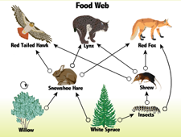

Grasp it

Competition
1. Define the term ‘interspecific competition’
2. Define the term ‘intraspecific competition’
3. Why do plants not compete with each other for food?

Adaptations
4. Why do polar bears have small ears?
5. Why do cacti have spines instead of leaves?
6. Why are owls nocturnal?
7. Why do birds fly south for the winter?
8. Why do hedgehogs have spikes?
9. Why do leaves lose their leaves in the winter?
10. Why do cheetahs have muscular legs?

Variation
11. Two identical twins have different hair lengths – explain whether this is inherited or environmental variation
12. Explain why your height is influenced by both inherited and environmental variation
13. What graph would you produce to display the data collected if you surveyed the eye colour of the class?
14. What graph would your produce to display the data collected if you surveyed the heights of the class

Inheritance
15. Why do sperm and egg cells contain 23 chromosomes?
16. Describe what happens during fertilisation

Natural Selection
17. Describe the stages involved in natural selection and how that leads to evolution of the species.
18. Explain how giraffes have evolved over generations to have longer and longer necks. Hint – think about their food source

Extinction
19. Give an example of a species that has become endangered or extinct for each of the reasons listed
Know it

Competition
1. List 4 resources that animals compete for
2. List 4 resources that plants compete for

Adaptations
3. Why do polar bears have large paws?
4. Why do cacti have thick stems?
5. Why do owls have good eyesight?
6. Define the term ‘adaptation’

Variation
7. Define the term ‘variation’
8. Give 3 examples of inherited variation
9. Give 3 examples of environmental variation
10. Give 3 examples of variation caused by both inherited and environmental factors

Inheritance
11. Where, in a cell, is the DNA stored?
12. What is ‘DNA’?
13. Define the term ‘Chromosome’
14. Define the term ‘Gene’
15. Which cells do not contain 46 chromosomes?

Natural Selection
16. Define the term ‘survival of the fittest’
17. Define the term ‘natural selection’

Extinction
18. Define the term ‘extinction’
19. Define the term ‘biodiversity’
20. State 5 reasons why a species might become extinct
21. What is a ‘gene bank?’
22. Name 2 extinct species
23. Name 2 endangered species
24. What evidence do we have of past extinct species?

