**7.8 – Sound**

**2. Sound and Energy Transfer**

**What do I need to be able to do?**

•Describe waves on water as undulations which can be reflected and add or cancel – superposition.

•Describe frequencies of sound waves, measured in hertz (Hz); echoes, reflection and absorption of sound

•Understand that sound needs a medium to travel, the speed of sound in air, in water, in solids

•Describe sound produced by vibrations of objects, in loudspeakers, detected by their effects on microphone diaphragm and the ear drum; sound waves are longitudinal

•Know the auditory range of humans and animals.

•Describe pressure waves transferring energy; use for cleaning and physiotherapy by ultra-sound; waves transferring information for conversion to electrical signals by microphone.

**3. Loudness and Pitch**

**Frequency, f,** is the number of oscillations per second, measured in **Hertz** (Hz).

In a sound wave, the frequency determines the **pitch**. Low f = Low pitch.

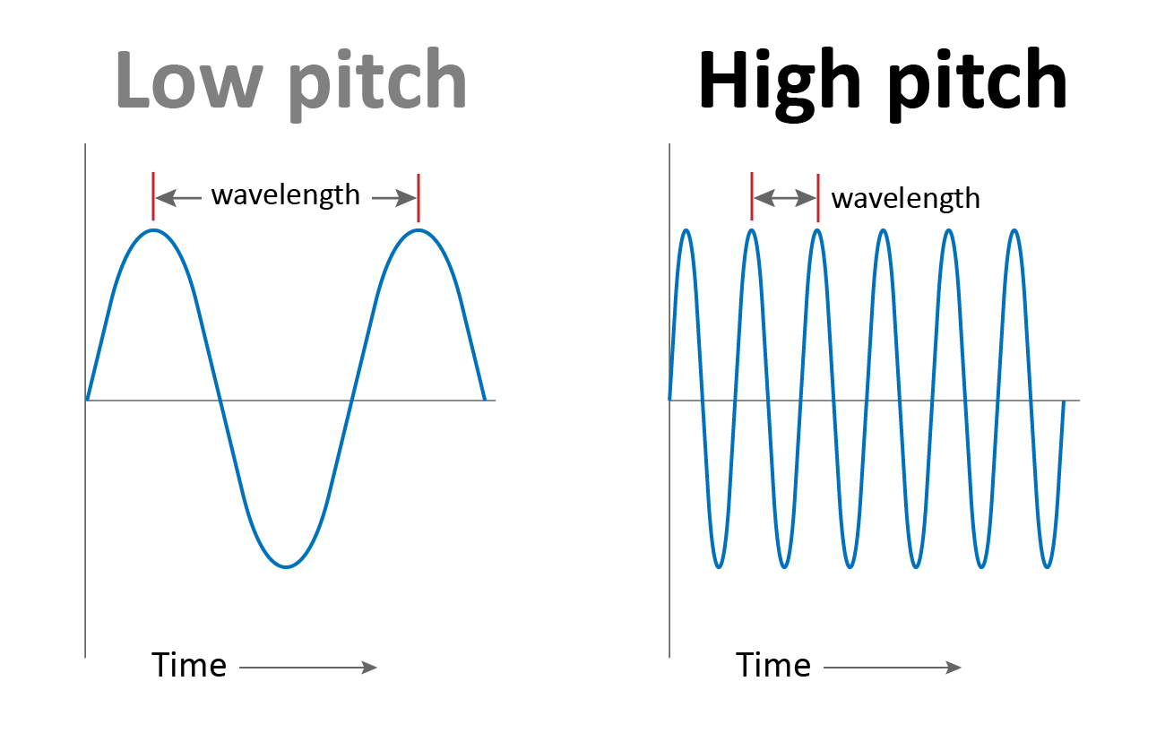

The **amplitude, A,** is the maximum height of a wave.

In a sound wave, the amplitude is the **loudness**. Higher A = louder sound.

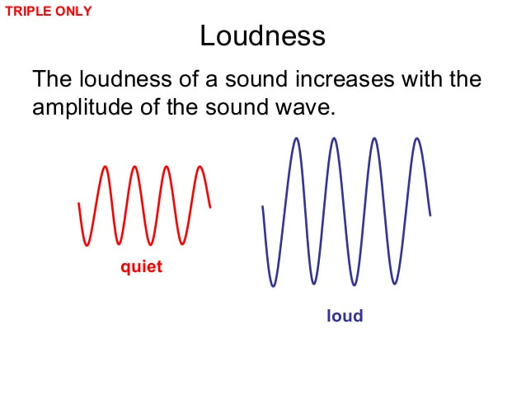

**1. Waves**

We **see lightning** before we   
**hear the thunder**.

This is because light travels  
much faster than sound.

* Light travels at 300 000 000 m/s.
* Sound travels at 330 m/s

**Oscillation** is the scientific word for “vibration”.

The tuning fork **oscillates** and you   
hear a sound.  
  
Sounds are made when an object   
oscillates. Sound travels because the vibrating object makes nearby particles oscillate.

A **medium** is a substance waves move through.

**Waves** transfer **energy** without any overall transfer of **matter**.

**Transverse** waves oscillate **perpendicular** to the direction of energy transfer, e.g. **Light**

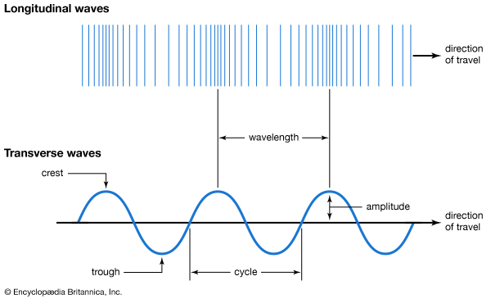

**Longitudinal** waves oscillate **parallel** to the direction of energy transfer, e.g. **Sound**







**4. Detecting Sound – The Ear**

**7. Measuring Waves**

**5. Detecting Sound – The Microphone**

**6. Echoes and Ultrasound**

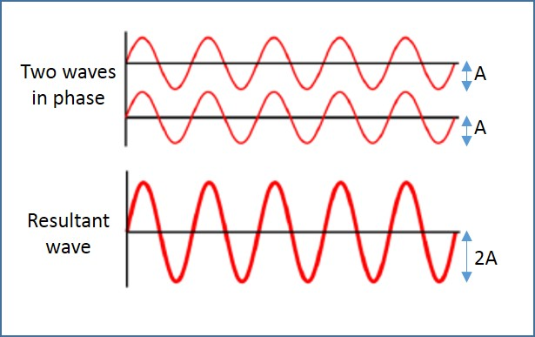



**The microphone:**

* The sound waves hit the **diaphragm**
* This causes the diaphragm to oscillate
* The **coils of wire** and **magnet** behind the diaphragm work together to produce an electric signal
* This is sent as an **audio signal** through cables

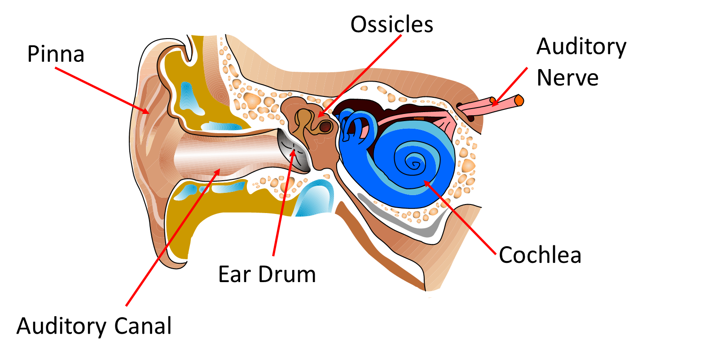

**How we hear!**

* The **pinna** collects the sound wave
* The sound waves move through the **auditory** canal
* The sound waves cause the **ear drum** to oscillate
* The **ossicles** amplify the oscillations
* The **cochlea** turns these oscillations into electrical signals
* The signals travel up the **auditory nerve**, to the brain.

When a sound wave hits a surface, it is **reflected** and heard a little time later. This is known as an **echo**.

The delay in hearing the sound is dependent on the distance the wave has to travel.

**Distance (m) = speed (m/s) x time taken (s)**

**Ultrasound** is sound with a frequency of **above 20 kHz** (20,000 Hz) **1 kHz = 1,000 Hz**

Uses of Echoes & Ultrasounds:

* **Mapping** the sea floor
* **Scanning** unborn babies
* **Detection** of surroundings for some animals including Bats and Dolphins (Echolocation)



As the two waves pass through each other they experience “**superposition**”. This means they combine to form a single wave.

We can use **experiments**   
to measure various   
**properties** of waves.   
Scan the QR code on this   
section for an example   
of a step-by-step   
method.

|  |  |
| --- | --- |
| **Key term** | **Definition** |
| Conservation | Kept the same. |
| Exothermic | Reaction that releases energy to the surroundings |
| Endothermic | Reaction that absorbs energy from the surroundings |
| Reaction | When bonds are broken between atoms, atoms rearranged, and new bonds formed between them |
| Rate | The speed of a reaction. The mass/volume of product produced every second |
| Respiration | Reaction that released energy from the chemical energy store of glucose |
| Photosynthesis | Reaction in which light energy is used by plants to produce glucose |
| Thermal decomposition | Reaction in which compounds are broken down into simpler compounds and elements |
| Combustion | Releasing energy from a chemical store (fuel) by reacting with oxygen |
| Fuel | A chemical store of energy |
| Global warming | The effect of the increasing temperature of the Earth |
| Limewater | A solution of aqueous calcium hydroxide that is used to test for the presence of carbon dioxide |
| Catalyst | A substance added to a reaction to increase the rate |
| Cells | The basic unit of all living organisms |

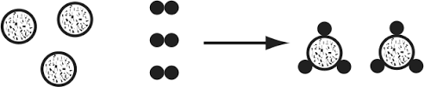

**Link it**

**1.** Explain why changes of state are endothermic processes.

**Hint – revisit 7.2 Particles and their Behaviour**

**2.** Explain why each of the 3 bullet points over leaf for catalysts, make them beneficial for use in industry

**3.** Which of the below sets of data show a catalysed reaction? Explain how you know, using data in your answer.

|  |  |
| --- | --- |
| Time (s) | Mass of product produced (g) |
| 10 | 2 |
| 20 | 4 |
| 30 | 6 |
| 40 | 8 |

|  |  |
| --- | --- |
| Time (s) | Mass of product produced (g) |
| 20 | 2.5 |
| 40 | 5 |
| 60 | 6.5 |
| 80 | 8 |

Plot both sets of data on a graph. Use graph paper, pencil and ruler, or a graph plotting programme or website.

**4.** Construct a balanced symbol equation for the combustion of pentane (C5H12)

**5.** Construct a balanced symbol equation for the thermal decomposition of zinc carbonate (ZnCO3)

**6.** Plan an investigation to determine which metal carbonate; copper carbonate, calcium carbonate and zinc carbonate, has the strongest bonds. Include details of;

•Independent variable

•Dependent variable and how it will be measured

•Control variables and how you will control them

•How you will know which metal carbonate had the strongest bonds

**Know it**

**Physical & Chemical Changes**

1. Give 3 examples of a physical change

2. Give 3 examples of a chemical change

3. Describe what happens during a chemical reaction

4. Give 3 observations that a chemical reaction has occurred

5. define the term ‘observation’

**Conservation of mass**

6. If there are 10g in total of reactants, what mass of products are there in total?

7. Explain your answer to question 6

**Exothermic and Endothermic**

8. Define the term ‘exothermic reaction’

9. Define the term ‘endothermic reaction’

10. How could you tell, in an investigation, if a reaction is exothermic?

11. How could you tell, in an investigation, if a reaction is endothermic?

12. Give 3 examples of exothermic reactions or processes

13. Give 3 examples of endothermic reactions or processes

**Combustion**

14. Define the term ‘fuel’.

15. What gas in the air does the fuel react with, when it is combusted?

16. What two products are always formed when a fuel is combusted in a plentiful supply of air?

**Thermal Decomposition**

17. Define the term ‘thermal decomposition’

18. Describe the test for the presence of carbon dioxide

**Photosynthesis & Respiration**

19. Write a word equation for respiration

20. State where respiration occurs

21. Write a word equation for photosynthesis

22. State where photosynthesis

**Catalysts**

23. Define the term ‘catalyst’

**Grasp it**

**Conservation of mass**

1. If 6g of hydrogen reacts with 28g of nitrogen, what mass of ammonia is produced?

2. Explain how this diagram shows the conservation of mass.

3. Balance this equation

C + O2 🡪 CO

4. Balance this equation

Al + Cl2 🡪 AlCl3

5. Balance this equation

TiCl4 + Mg 🡪 Ti + MgCl2

**Exothermic and Endothermic**

6. Describe how a self-heating can works

7. Why does the temperature of the surroundings decrease in an endothermic reaction?

**Combustion and Thermal Decomposition**

8. Write a word equation for the combustion of propane

9. Write a word equation for the combustion of octane

10. Is a combustion reaction, exothermic or endothermic? Explain how you know.

11. Explain the negative effects of carbon dioxide on the Earth.

12. Explain why combustion can also be considered an oxidation reaction

13. What mass of oxygen does 30g of ethane react with to produce 88g of carbon dioxide and 54g of water

14. Write a word equation for the thermal decomposition of zinc carbonate

15. What mass of carbon dioxide is produced if 100g of calcium carbonate is decomposed into that, and 56g of calcium oxide