Stage 11 Non-Negotiables (Corbett Maths video number in brackets)
- Find the diagonal through a cube or cuboid. (259)
- Find the angle between a line and a plane. (332)
- Use the Sine Rule to find sides (333)
- Use the Sine rule to find angles (334)
- Use the Cosine Rule to find sides (335)
- Use the Cosine Rule to find angles (336)
- Use the area of a triangle formula (337)
- Rationalise a denominator (307)
- Expand brackets with a surd (308)
- Complete the square (10)
- Use the Quadratic formula (267)
- Use an iterative formula (373)
- Find composite functions (370)
- Find inverse functions (369)
- Use inverse and direct proportion (254-255)
- Generate a geometric sequence (375)
- Solve a quadratic inequality (378)
- Transform a graph using f(x) (323)
- Find the equation of a tangent to a circle (372)
- Use vectors to prove lines are parallel (353)

Skill | Method | Keywords/Definitions
1101 | Find the diagonal through a cube or cuboid (259)  The trick with these is being able to identify the right-angle triangles contained within a 3D shape.  Example:  Find the length AG in this cuboid  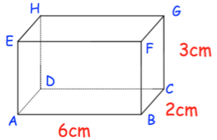  AG is the hypotenuse of the triangle ACG and we already know that the height of this triangle, GC is 3cm so if we can find AC we can use pythagoras to fid AG.  To find AC we need to use Pythagoras on the base $\sqrt{6^{2}+2^{2}}$=6.32 (keeping this as $\sqrt{40}$) will stop any loss of accuracy)  So, we now do Pythagoras with 3cm and $\sqrt{40}$cm: $\sqrt{3^{2}+{\sqrt{40}}^{2}}$=7cm  Note: given the nature of what we’re doing here (squaring and square rooting etc) this can be done as one big Pythagoras sum: $\sqrt{6^{2}+2^{2}+3^{2}}=7cm$
1102 | Find the angle between a line and a plane. (332)  Again, this is an exercise in identifying the right triangles in a 3D shape then applying trigonometry and Pythagoras.  Example  Find the size of angle ACE in this cuboid:  The angle ACE is part of the right triangle ACE so we have a right triangle with AE as the opposite and AC as the adjacent (EC is the hypotenuse but we won’t use that). Therefore, to calculate the angle we need to know the length AC then we can use tan.  Use Pythagoras to find AC $\sqrt{6^{2}+2^{2}}=6.32$ keeping as $\sqrt{40}$ again means no loss of accuracy.  So, to find the angle ACE we can do $\tan^{-1}{(\frac{3}{\sqrt{40}})}$=25.4º
1103 | Use the Sine Rule to find sides (333)  It’s crucial for any of the following skills that you can label a non right angle triangle with sides a, b, c, and angles A, B, C:  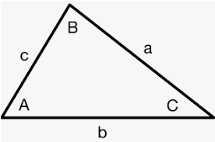 Notice that angle A is opposite side a, angle B is opposite side b etc  The Sine Rule states:  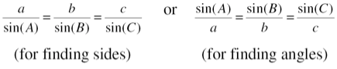 Only use the parts of these formulae that you need.  Example:  Find the missing side x on this triangle:  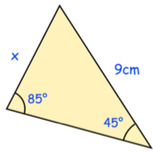  With any of these further trig questions, always label what you are trying to find (the x here) with the letter a (A if it is an angle) and the other angles and sides accordingly:  I’ve used aA and bB here but you could have used cC if you wanted to as well.  This means we can use the first part of the Sine rule:  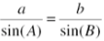 inputting our labelled values becomes  $$\frac{a}{\sin{45}}=\frac{9}{\sin{85}}$$  Multiply the fraction on the right by $\sin{45}$ to give  $$a=6.39cm$$
1104 | Use the Sine rule to find angle (334)  Example:  Find the size of the angle $θ$in this triangle:  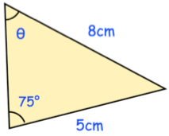  Again, like the previous skill, label the angles AB and sides ab, making sure what you’re trying to find is A (as it’s an angle this time)  This time as we’re finding an angle, the formula is flipped:  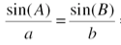 and inputting our labelled values this becomes:  $$\frac{\sin{A}}{5}=\frac{\sin{75}}{8}$$  Multiplying by the 5 gives us $\sin{A}=0.60370…..$  To get the size of the actual angle A, we need to do inverse sine here:  $\sin^{-1}{0.6037036414}$ (better to use the memory function on the calculator and input $\sin^{-1}{(ANS)}$ to prevent any loss of accuracy)  This gives us an answer of 37º
1105 | Use the Cosine Rule to find sides (335)  Like the Sine rule this requires you to be able to lable the sides abc and angles ABC of a non right triangle.  The Cosine Rule states:  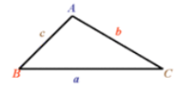 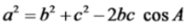or 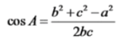  Example:  Find the side labelled x on this triangle  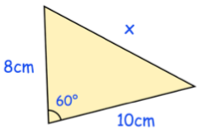  Start by labelling the sides.  Label what you are trying to work out as a (lower case as it’s a side) and it doesn’t matter about the 8 being either b or c or the ten vice versa.  As we’re working out a side, we use  Which becomes this once we put in our labelled values $x^{2}=8^{2}+{10}^{2}-2(8)(10)\cos{(60)}$  This gives us $x^{2}=84, s$o we need to square root to give the answer 9.2cm
1106 | Use the Cosine Rule to find angles (336)  Example:  Find the size of the angle $θ$ in this triangle  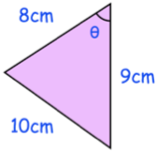  Label the sides:  Again, label what you’re working out A (capital as its an angle) and the b and c could be the other way round, but the 10 must be the a as its opposite the A.  This time we’re finding an angle, so we need this version of the formula:  Replacing the letters with our labelled values gives us: $\cos{A}=\frac{8^{2}+9^{2}-{10}^{2}}{2(8)(9)}$ which gives $\cos{A}=\frac{5}{6}$  We therefore need to do $\cos^{-1}{\frac{5}{6}}$ to give us our answer of 72º  It’s important to notice that we couldn’t use the sine rule on this triangle as we don’t have a pair Aa, Bb or Cc to use, so must use the Cosine Rule!
1107 | Use the area of a triangle formula (337)  Again, labelling the sides properly is crucial for this. The formula you need is  Example:  Calculate the area of this triangle  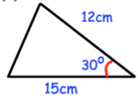  Label the sides (this time, you need to label your angle as C, which makes the other two sides a and b)  Putting our labelled values into the formula gives us:  $$area=\frac{1}{2}(12)(15)\sin{(30)}$$  Which gives us an answer of 77.9cm²  It’s important to note that this only works if you have Side Angle Side around the corner of a triangle. So, for example it wouldn’t work on the following triangle:
1108 | Rationalise a denominator (307)  Rationalising a denominator means getting rid of any surds on the bottom of a fraction. This is important as if surds are irrational (ie can’t be properly expressed) we can’t be dividing by something we can’t properly write down or quantify. It’s a little like trying to divide by zero, it throws up the same issues.  We can’t just square the top and the bottom of a fraction as that changes the value of a fraction, but we can multiply the top and bottom by the same thing.  Example 1:  Rationalise the denominator  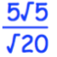  As there’s a $\sqrt{20}$ on the bottom, multiply the top and bottom by $\sqrt{20}$  We can tidy this up as both 100 and 400 will square root to give 10 and 20 respectively:  $$\frac{5×10}{20}=\frac{50}{20}=\frac{5}{2}$$  Example 2:  Rationalise the denominator  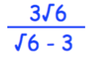  When we have more than one term on the bottom we need to multiply by the conjugate to that expression (the same expression just with the + turned to a – or vice versa).  (note you’ll need the next skill to be able to do this bit)  This gives us:  $$\frac{3\sqrt{36}+3\sqrt{18}}{\sqrt{36}+\sqrt{18}-\sqrt{18}+\sqrt{9}}$$  The plus and minus $\sqrt{18}$ terms in the denominator cancel each other out and the other roots will give us 6 and 3 respectively. So we get:  $$\frac{3×6+3×3\sqrt{2}}{6+3}$$  Which simplifies to  $$\frac{18+9\sqrt{2}}{9} which simplifies to 2+\sqrt{2}$$
1109 | Expand Brackets with a Surd (308)  Use the same algebraic rules to multiply out the brackets then simplify the surds  Example  Expand and simplify  F: $3\sqrt{5}×2\sqrt{5}=6\sqrt{25}$  O: $3\sqrt{5}×1=3\sqrt{5}$  I: $7×2\sqrt{5}=14\sqrt{5}$  L: $7×1=7$  So, the un-simplified version looks like this:  $$6\sqrt{25}+3\sqrt{5}+14\sqrt{5}+7$$  The first term simplifies to $6×5$ and the two middle terms (these are like terms as the both have $\sqrt{5}$ in them) simplify:  $$30+17\sqrt{5}+7$$  Finally simplify by adding the two integers 30 and 7 to get  $$37+17\sqrt{5}$$
1110 | Completing the square (10)  Take a quadratic and write is as a bracket squared with a number at the end. Questions will normally say Write in the format (x+a)²+b  Example:  Halve the -12 and this goes in the bracket squared with the x:  $(x-6)^{2}+3$  However, if we were to expand the $(x-6)^{2}$ we’d get $x^{2}-12x+36$  The $x^{2}and the-12x$ are fine as they are in our original expression, however the +36 needs to be cancelled out so we put a -36 at the end:  $$(x-6)^{2}+3-36$$  Then just simplify the two integers at the end:  $$(x-6)^{2}-33$$
1111 | Use the Quadratic Formula (267)  You need to remember this:  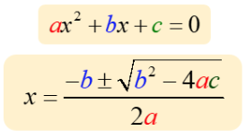  Example:  Solve this equation giving your answer correct to 2 decimal places  The equation already equals zero so we can use the formula straight away, if a quadratic does not equal zero you need to rearrange it first so that it does before using the formula.  In our equation $a=9, b=-12 and c=2$  So replacing the a, b and c in the formula with our values we get:  $$x=\frac{-(-12)±\sqrt{(-12)^{2}-4(9)(2)}}{2(9)}$$  The $±$ means we need to put this into our calculator twice, once with a + and once with a –  Our answers should then be $x=1.14 and x=0.20$  This is an incredibly important skill for anyone wanting to study A level maths.
1112 | Use an Iterative Formula (373)  Iteration is the process of repeating something again and again with better and better results each time. We us iteration to find solutions to equations that we have no algebraic method to locate. It is a lot easier than it looks!  Example  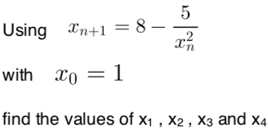  The $x_{n+1}$ represents the formula you will use: $8-\frac{5}{x^{2}}$ and the $x_{0}=1$ means we start by subbing 1 into this formula.  So the first line of working out would say $x_{1}=8-\frac{5}{(1)^{2}}=3$so, our first answer is 3  We now sub our answer into the formula again to get the next answer. So, $x_{2}=8-\frac{5}{(3)^{2}}=7.4444444444 or 7.\dot{4}$  We now sub this back into the formula to get our third answer. So $x_{3}=8-\frac{5}{7.\dot{4}}=7.328258208$  And finally sub this answer into the formula to get the last answer we’re asked for: $x_{4}=8-\frac{5}{7.328}$=7.317718941  You can use the memory function on the calculator to save you having to input the same function each time:  Press 1 then = on the calculator then input $8-\frac{5}{ans^{2}}$ and then each time you press = you will get the next answer.  Read the question carefully with these as they may ask you to write your answers differently, but the process will always be the same.
1113 | Find Composite Functions (370)  Composite functions are where we do one function and then the other, always starting with the one closest to the number or letter.  Example:  Given the functions: $f\left(x\right)=x^{2}+5$ and $g\left(x\right)=3x-2$  Find $fg(3)$  This means sub 3 into the function g, then sub the answer into the function f (always start with the one nearest the number then work your way outwards)  So $g\left(3\right)=3\left(3\right)-2=7$  And $f\left(7\right)=(7)^{2}+5=54$  You could also be asked to find an expression for a composite function, this means sub one function into the other.  Example:  Given the functions: $f\left(x\right)=x^{2}+5$ and $g\left(x\right)=3x-2$  Find an expression for $gf(x)$  This means replace the $x$in the function $g(x)$ with the function $f(x)$  $$gf\left(x\right)=3\left(x^{2}+5\right)-2$$  Which simplifies to  $$gf\left(x\right)=3x^{2}+15-2$$  And finally:  $$gf\left(x\right)=3x^{3}+13$$
1114 | Find Inverse Functions (369)  The inverse function means the opposite of what the function does usually. $f^{-1}(x)$ means the inverse function of x.  This can be done just by looking, if it’s a simple function:  Given $f\left(x\right)=2x+3$ the function here is ‘times by two and add 3’ so the inverse must be ‘minus 3 and divide by 2’  So $f^{-1}\left(x\right)=\frac{x-3}{2}$  However, if the inverse function isn’t obvious you can follow these instructions:  Given $g\left(x\right)=\frac{4x+9}{3x}$ find $g^{-1}(x)$  Step one: replace the function notation with the letter $y$:  $y=\frac{4x+9}{3x}$  Step two: make $x$ the subject of this formula  $$3xy=4x+9$$  $$3xy-4x=9$$  $$x\left(3y-4\right)=9$$  $$x=\frac{9}{(3y-4)}$$  Step three: swap the y and x  $$y=\frac{9}{(3x-4)}$$  Final step: write it with the correct function notation at the start instead of the y:  $$g^{-1}\left(x\right)=\frac{9}{(3x-4)}$$
1115 | Use Inverse and Direct Proportion (254-255)  Proportion (or proportionality) is where there is a clear link between two variables, so that a change in one causes a predictable change in the other. Note that this is not the same as correlation where one does not cause the other.  Direct Proportion  If one variable (letter) is directly proportional to another we can use the $∝$ symbol to represent this.  If $y$ is proportional to $x$ then we write this as $y∝x$  This means that there is a multiplication link between $x$and $y$, so that as one increases the other will increase.  We can translate this as follows:  If $y∝x$ then $y=kx$ where $k$ is a number that we will find.  Example:  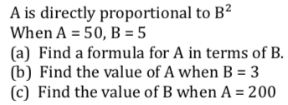  - The first line means we can write  $$A∝B^{2}$$  So $A=KB^{2}$  We can then use the pair of values in the second line, subbing A=50 and B=5 in so that we get an equation with only K in it:  $$\left(50\right)=k\left(5^{2}\right)$$  $$50=25k$$  So $k=2$  This means the equation linking A and B must be $A=2B^{2}$  - Subbing B=3 into the formula found in part a we get:  $$A=2\left(3^{2}\right)$$  So $A=18$  - Subbing A=200 into the equation found in part a we get:  $$200=2B^{2}$$  $$100=B^{2}$$  $10=B$ (B technically should equal either plus or minus 10 here as when we square root we get both a positive and negative answer)  Inverse Proportion  If one variable is inversely proportional to the other it means that it is linked through division instead of multiplication. So this changes the initial set up equations to $y∝\frac{1}{x}$ and then $y=\frac{k}{x}$ and means that as one variable increases, the other will decrease.  Example:  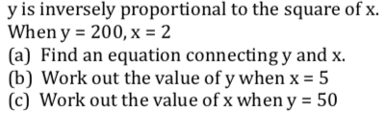  - $y∝\frac{1}{x^{2}}$  So $y=\frac{k}{x^{2}}$  Subbing in the values $y=200$ and $x=2$ gives us:  $$\left(200\right)=\frac{k}{(2)^{2}}$$  $200=\frac{k}{4}$ multiply by the 4 here to get that $k=800$  So, the equation linking x and y is:  $$y=\frac{800}{x^{2}}$$  - Sub $x=5$into the equation found in part a:  $$y=\frac{800}{(5)^{2}}=\frac{800}{25}=16$$  - Subbing $y=50$into the equation gives:  $50=\frac{800}{x^{2}}$ (multiply by the $x^{2}$and divide by the 50, so they swap places)  $$x^{2}=\frac{800}{50}$$  $x^{2}=16$  So $x=4$ (or minus 4)
1116 | Generate a Geometric Sequence (375)  A geometric sequence is one where to get from one term to the next we multiply the terms by the same number each time. This is called the ‘common ratio’.  Example:  Find the next two terms in this sequence  2, 6, 18, 54…..  The common ratio here is 3 as you are multiplying by 3 each time. So $54×3$=162 and $162×3=486$  The general formula for a geometric sequence is  $$ar^{n-1}$$  Where $a$is the first term and $r$ is the common ratio.  Example:  Give the first 4 terms in the geometric sequence with a first time of 10 and a common ratio of 3  1st term: $10×3^{1-1}=10$  2nd term: $10×3^{2-1}=30$  3rd term: $10×3^{3-1}=90$  4th term: $10×3^{4-1}=270$  You could do this without using the formula $ar^{n-1}$ but just starting with 10 and multiplying by 3 each time, but you will calculate more deeply with this at A level so it is important to be aware of this formula.
1117 | Solve a Quadratic Inequality (378)  Very similar to solving quadratic equations, you just need to think about which inequalities your roots will give you.  Example  Factorise the quadratic to get  $$(4x+1)(x-1)≥0$$  This gives us roots of $-\frac{1}{4}$ and +1 from the brackets.  This allows us to sketch the graph of the parabola, and we now know it crosses the x-axis at $-\frac{1}{4}$and 1:  We not need to look back at the original inequality. This says $≥0$ which means we want the parts of the graph ABOVE the x-axis. We can see that the parts above the x-axis are to the left of the $-\frac{1}{4}$ and the right of 1.  So, this gives us answers of $x≤-\frac{1}{4}$ and $x≥1$
1118 | Transform and graph using f(x) (323)  You just need to remember the rules given here  If the transformation is inside the bracket, it affects the graph in the x-direction (horizontally). If it is outside the bracket it affects it in the y-direction (vertically).  A negative sign reflects the graph.  A + or – translates it  A multiplication or division stretches the graph.  If numbers appear inside the bracket they do the opposite that you would imagine. For example f(x+2) moves the graph 2 units LEFT.  Examples:  The graph $y=f\left(x\right)$ is shown  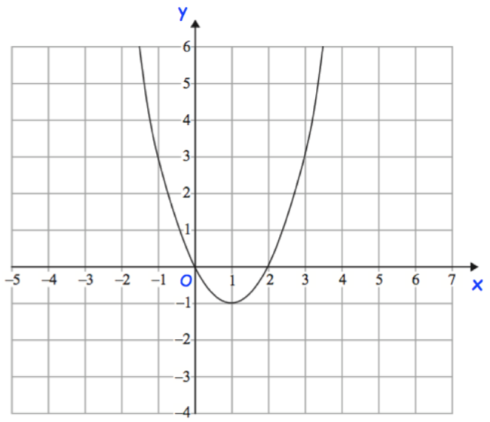  Sketch the graphs of:  - $y=f(-x)$ the negative means it will be reflected and its inside the bracket so it reflects in the horizontal direction  - $y=f\left(x-3\right)-2$ the -3 is inside with the x so moves it 3 RIGHT (opposite to what you’d think) the -2 is outside so moves it 2 down  - $y=2f(x)$this is a multiplication vertically (outside the bracket)  Notice on this that the roots of the graph (where it crosses the x-axis) stay in the same place.
1119 | Find the equation of a tangent to a circle (372)  It’s important here to know that the formula for a circle is always $x^{2}+y^{2}=r^{2}$ where $r$ is the radius of the circle and the centre of the circle is (0,0)  Example:  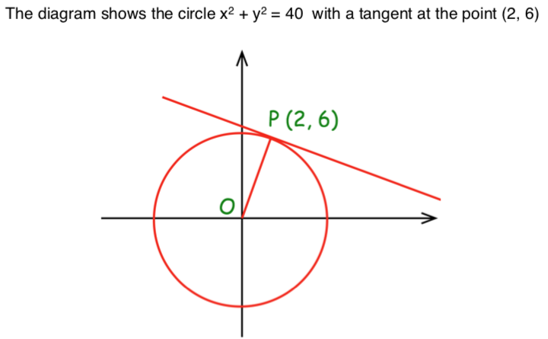  1st step: Find the gradient of the radius between the centre and the tangent  $$\frac{∆y}{∆x}=\frac{6}{2}=3$$  2nd step: tangents are always perpendicular to the radius so the gradient of the tangent will be the negative reciprocal of the gradient of the radius $-\frac{1}{3}$  3rd step: we now have the gradient of the tangent so we know that the equation will be $y=-\frac{1}{3}x+c$so to find c we sub in the coordinate we have $(2,6)$ which means x=2 and y=6  $$\left(6\right)=-\frac{1}{3}\left(2\right)+c$$  $$6=-\frac{2}{3}+c$$  $$\frac{22}{3}=c$$  4th step: put everything together, so your equation is: $y=-\frac{1}{3}x+\frac{22}{3}$
1120 | Use Vectors to Prove Lines are Parallel (353)  One vector is parallel to another if they are multiples of each other (20a+12b is a multiple of 5a+3b)  Example  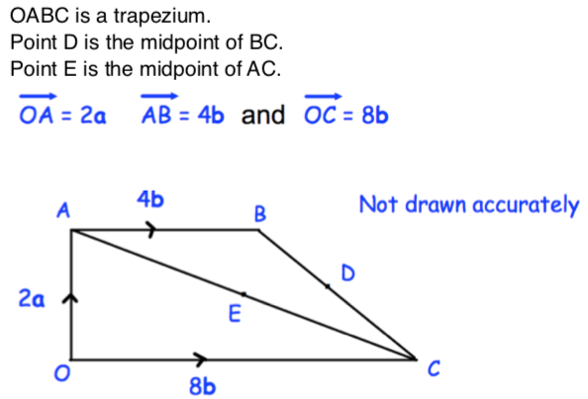  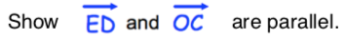  $\vec{OC}=8b$ so we don’t need to work anything out there, we can just concentrate on finding $\vec{ED}$  The point E is the midpoint of the line $\vec{AC}$ and $\vec{AC}$ can be expressed as -2a+8b  So, $\vec{EC}$ will be halve of this$=-a+4b$  D is the midpoint of $\vec{BC}$ and $\vec{BC}$ can be expressed as $-4b-2a+8b$ or $-2a+4b$  So, $\vec{DC}$can be expressed as halve of this $=-a+2b$  $$\vec{ED}=\vec{EC}+\vec{CD}$$  $$\vec{ED}=-a+4b-(-a+2b)$$  In the line above we have to subject $\vec{DC}$ as we want to go backwards  $$\vec{ED}=2b$$  So, if $\vec{OC}=8b$ and $\vec{ED}=2b$ we can see that these are multiples of each other, therefore the two lines are parallel.

