**8.3 – The Periodic Table**

**Trends down the group**

•melting and boiling points decrease

•hardness decreases

•reactivity increases

***When group 1 metals react with water:***

Lithium + water 🡪 lithium hydroxide + hydrogen

**2Li + 2H2O 🡪 2LiOH + H2**

**All other group 1 metals react with water in this way.**

**3. Group 1: The Alkali Metals**

**What do I need to be able to do?**

•Describe the varying physical and chemical properties of different elements

•Understand the principles underpinning the Mendeleev Periodic Table

•Understand the arrangement of the Periodic Table: periods and groups; metals and non-metals

•Understand how patterns in reactions can be predicted with reference to the Periodic Table

• Describe the properties of metals and non-metals

•Use and interpret the Periodic Table

•Make predictions based on trends in chemical and physical properties

•Classify and compare properties of metal and non-metals

• Link properties of metal and non-metals to uses

•Record observations and cognise trends and patterns

**2. Metals and Non-metals**

**1. The Periodic Table**

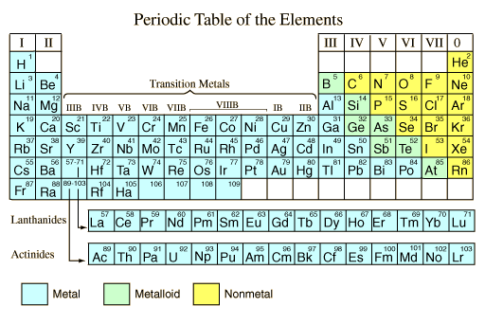

The Periodic Table displays all the **elements** that exists so far, on the Earth.  
  
Elements are arranged in order of increasing number of **protons**, from left to right.

***See Box 6 for a recap on proton number.***

Each element is represented in a box like the following. We can gain the following information from it:

The columns of the Periodic Table are called **groups** – all elements in the same group share similar chemical properties.

The rows of the periodic table are called **periods.**



A flammable gas

**Observation**; fizzing/bubbling/fumes, flames

Dissolves in the water to produce an alkaline solution – hence the name alkali metals.

**Observation**; universal indicator will turn purple

Metal elements are found to the left of the Periodic Table and non-metal elements are found to the right.

Metals and non-metals have different properties:

|  |  |
| --- | --- |
| Metals | Non-metals |
| Good conductors of heat and electricity | Insulators of heat and electricity |
| High melting and boiling point | Low melting and boiling points |
| Lustrous | Dull |
| Shiny when cut |
| Malleable | Brittle |
| Ductile |

There are some exceptions to these properties.  
  
  
  
metal

**Mass number** – number of protons + number of neutrons

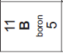

**Element symbol**

•

**Proton number** – number of protons



**Scan here to watch the reactions of group 1 metals and water**

**6. Atomic Structure Recap**

**4. Group 7 – The Halogens**

**5. Group 0 – The Noble Gases**

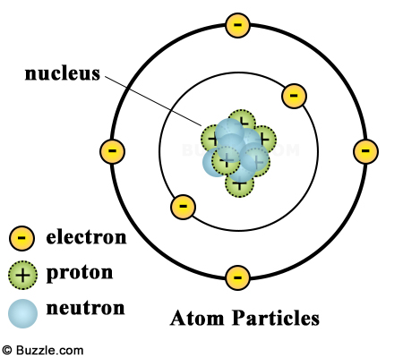

**Displacement reactions** occur when a **less** reactive element in a compound is removed and replaced (**displaced**) by a **more** reactive element

e.g.

**sodium chloride + fluorine 🡪 sodium fluoride + chlorine**

Fluorine is more reactive than chlorine and so replaces it in the compound. Chlorine is removed as an element…

…But with lithium bromide and iodine, there is no reaction. Iodine is below bromine in the Periodic Table and therefore less reactive. It cannot displace bromine from its compound.

When writing balanced symbol equations, remember halogens are diatomic molecules when in their elemental form;

e.g.

**sodium chloride + fluorine 🡪 sodium fluoride + chlorine**

2NaCl + F2 🡪 2NaF + Cl2

**Trends down the group**

•melting and boiling points increase

•colour gets darker

•reactivity decreases

**Reacting with group 1 metals:**

A salt is made.

*Hint – see 7.10 Acids & Bases for a recap on salts*

The suffix of the halogen changes from **-ine** to **-ide.**

e.g. sodium + chlor**ine** 🡪 sodium chlor**ide**

lithium + brom**ine** 🡪 lithium brom**ide**

**Trends down the group**

•Melting and boiling points increase

•Density increases

The Noble Gases are **colourless, inert** (unreactive) gases. It is these properties that make them useful in the following situations:

*•Helium is used to fill balloons as it is less dense than air and therefore will float*

*•Argon is used to fill filament lamp bulbs. This is because it is unreactive and non-flammable. It will not react with the metal filament as it glows.*

**Mass number** – number of protons + number of neutrons



**Proton number** – number of protons





**🡨 Scan here for more information about the uses and properties of group 0 elements**

Mass number (11) is the number of protons plus the number of neutrons. We know there are 5 protons. *So how many neutrons are there?*

Mass number (11) – proton number (5) = 6 neutrons

**Scan here for more information about the uses and properties of group 7 elements**

|  |  |
| --- | --- |
| **Key term** | **Definition** |
| Element | Substance in which all the atoms contain the same number of protons |
| Proton | Positively charged sub-atomic particle with a mass of 1 |
| Mass number | Sum of the number of protons plus the number of neutrons |
| Proton number | Number of protons in the nucleus of an atom |
| Groups | Columns of the Periodic Table |
| Periods | Rows of the Periodic Table |
| Conductor | Allow energy to pass through the material |
| Insulator | Do not allow energy to pass through the material |
| Sonorous | Rings like a bell when hit |
| Malleable | Can be hammered into shape |
| Ductile | Can be drawn out into wires |
| Flammable | Catch fire easily |
| Salt | Compound formed from metal and non-metal atoms |
| Displacement | A more reactive element can replace a less reactive element in a compound |
| Diatomic molecule | A molecule containing 2 atoms. |
| Neutron | A sub-atomic particle with no charge but a mass of 1 |
| Electron | A negatively charged sub-atomic particle with an insignificant mass |
| Nucleus | Central part of an atom containing the protons and neutrons |
| Inert | Unreactive |
| Density | Mass per unit of volume |

**Know it**

**The Periodic Table**

1. What is the Periodic Table arranged in order of?

2. What do we call the columns of the Periodic Table?

3. What do we call the rows of the Periodic Table?

4. What does the mass number of an element tell us about it’s atoms?

5. Using your Periodic Table – how many protons are in atoms of calcium?

**Metals & Non-metals**

6. Describe 3 properties of metals

7. Describe 3 properties of non-metals

**Group 1: Alkali Metals**

8. Describe the trend in melting and boiling point down the group.

9. Describe the trend in reactivity down the group

10. What gas is produced during the reaction of group 1 metals and water?

**Group 7: The Halogens**

11. Describe the trend in melting and boiling point down the group.

12. Describe the trend in reactivity down the group

13. Name the product formed from the reaction of lithium and iodine

14. Name the product formed from the reaction of potassium and chlorine

**Group 0: The Noble Gases**

15. Describe the trend in the melting and boiling point down the group

16. Describe the trend in density down the group

17. Define the term ‘density’

**Atomic Structure Recap**

18. Name the positively charged sub-atomic particle

19. Name the negatively charged sub-atomic particle

**Grasp it**

**The Periodic Table**

Use your Periodic Table to help you answer these questions:

1. The atoms of which element contain 13 protons?

2. The atoms of which element contains 7 protons?

3. Which element is in period 2, group 1?

4. Which element is in period 4, group 2?

5. Which element is in period 3, group 4?

**Metals & Non-metals**

6. Define the term ‘good conductor’ of heat and electricity

7. Define the term ‘insulator’ of heat and electricity

**Group 1: Alkali Metals**

8. Write a word equation for the reaction between sodium and water

9. Write a word equation for the reaction between potassium and water

10. Write a balanced symbol equation for the reaction between sodium and water

11. Why does the universal indicator turn purple when added to the water in the reaction in Q10?

12. Why would you see fizzing and bubbling during the reaction in Q10?

**Displacement reactions**

12. Predict whether a displacement reaction will occur between the following substances. For any that will, write a full word equation, identifying all products

1. Lithium chloride + bromine
2. Sodium bromide + fluorine
3. Potassium bromide + iodine
4. Lithium fluoride + bromine
5. Lithium chlorine + bromine

**Group 0: The Noble Gases**

13. Why is neon used to fill tubes in neon lights?

**Atomic Structure Recap**

Use your Periodic Table to help you with this

14. How many neutrons are in atoms of boron?

15. How many neutrons are in atoms of fluorine?

**Link it**

**1.** Why are elements placed in the same group with other elements?

**2**. If 46g of sodium reacts with 32g of water to produce 2g of hydrogen. What mass of sodium hydroxide is produced?

**3.** A beaker of water is placed onto a mass balanced and the tare button is pressed. A piece of sodium is added to the water. As the reaction progresses, the mass decreases. Explain this observation and why it is not expected.

**4.** Compare the trends down the group for Group 1 and Group 7 elements.

**5.** Use your periodic table to help you predict the properties of Rubidium and Astatine

**6.a.** Compare the melting and boiling points and electrical conductivity of metals and non-metals.

**b.** Metals are usually solids at room temperature, but non-metals are usually gases or liquid at room temperature. Use your knowledge of the Particle Model to help you explain your answers to part a.

**7.** Explain the results in the table.

|  |  |  |  |  |
| --- | --- | --- | --- | --- |
| Halogen | Salt | | | |
|  | NaF | NaCl | NaBr | NaI |
| F |  | ✓ | ✓ | ✓ |
| Cl | 🗴 |  | ✓ | ✓ |
| Br | 🗴 | 🗴 |  | ✓ |
| I | 🗴 | 🗴 | 🗴 |  |

**8.** Argon is often used to fill the space between glass panes in double-glazed windows.

**a.** Explain why argon has this use.

**b.** If the glass was accidentally broken the argon would escape. Would this be safe?

Explain your answer.