**Current –** the rate of flow of electrical charge. In an electrical circuit this will be the rate of flow of electrons. It is measured in **amperes (amps, A)**

**Potential difference** – a measure of the differences in electrical potential energy between two points in a circuit, usually before and after a component. It is measured in **volts (V)**

The potential difference rating of a cell or battery is a measure of the ‘push’ it gives the current

A 12V cell will induce a higher rate of flow of charge than a 6V cell

**Resistance** – a measure of the difficulty for current to flow. Adding more components increases the resistance in the circuit. It is measured in **ohms (Ω)**

**As the resistance increases, the current decreases and the potential difference increases**

**2. Circuit Diagrams**

***7.4 - Atomic Structure recap***

Atoms are composed of the following sub-atomic particles:

• Protons – which are positively (+) charged

• Electrons – which are negatively (-) charged

•Neutrons – which have no charge

Opposite charges **( + and -)** attract each other

Like charges **( + and +, or, – and - )** repel each other

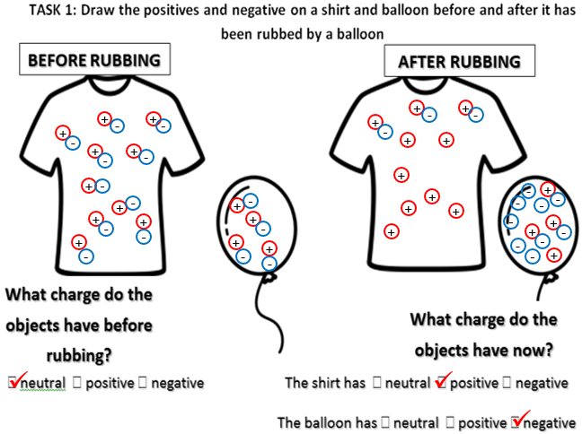

When the balloon is **rubbed** on something like hair or clothes, **friction** causes **electrons** to be transferred from your jumper to the balloon. This makes the balloon overall **negatively** charged. The jumper is now more **positively** charged compared to the balloon. The balloon is then **attracted** to the jumper. **This is static electricity.**

**8.8 – Electromagnetism**

**1. Static Electricity**

**What do I need to be able to do?**

•Understand; electric current, measured in amperes, in circuits, in series and parallel circuits,

•Understand; potential difference, measured in volts, battery and bulb ratings; resistance, measured in ohms, as the ratio of potential difference (p.d.) to current

•Understand the separation of positive or negative charges when objects are rubbed together: transfer of electrons, forces between charged objects

•Describe the idea of electric field, forces acting across the space between objects not in contact.

•Describe magnetic poles, attraction and repulsion

•Understand Earth’s magnetism, compass and navigation

•Describe the magnetic effect of a current, use in electromagnets

•Visualise magnetic fields by plotting with compass, representation by field lines

•Apply rules for current, p.d. and resistance in series and parallel circuits to identify missing values

**3. Definitions**

***Circuit Component Symbols:***

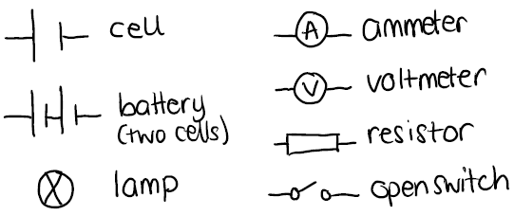

When drawing a circuit diagram, we connect the component symbols with straight lines (use a ruler) to represent wires

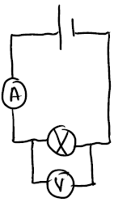

An **ammeter** is placed in **series** (in the same loop) to measure the **current through** a component

A **voltmeter** is placed in **parallel** (an additional loop) **across** the component to measure the **potential difference**.

**5. Parallel Circuits**

**7. Magnetism**

**4. Series Circuits**

**6. Calculating Resistance**

***Magnets can attract or repel other magnets:***

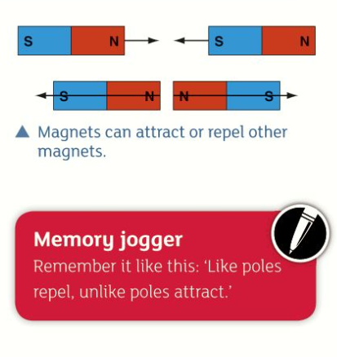

Magnets will **attract** magnetic materials that contain the elements **iron, nickel or cobalt**.

A magnetic field is the area around a magnet where a magnetic material will experience a force. This is a non-contact force as the object needs only to be brought into the field around the magnet, not to touch the magnet.

When a current flows through a wire, a magnetic field is produced. This is an electromagnet. ***The strength of the magnet can be increased by***:

•increasing the current flowing through the wire

•having more turns in the coil of wire

•coiling the wire around a magnetic metal core

**Electromagnets will stop being magnetic if the current is turned off.**

To find the resistance of a component, you need to measure:

• potential difference across it, in **volts (V)**

• current flowing through it, in **amps (A)**

**We can use the following equation to calculate the resistance of a component:**

**resistance (Ω) = potential difference (V)**

**÷**

**current (A)**

**e.g. 3A flows through a 240V lamp. What is the resistance?**

**E -** resistance = potential difference ÷ current

**V -** p.d. = 240 V current = 3 A

**E** - resistance = 240 ÷ 3

**R -** resistance = 80

**Y -** resistance = 80 Ω

The electrical components are connected one after another in a single loop.

If one component is broken, this creates a gap in the circuit and current cannot flow. This means that if a bulb breaks in a circuit, all others will go out as well.

**The current is the same at all points in a circuit**

**The potential difference of the cell or battery is shared across the components**

**The total resistance is the sum of all resistors in the circuit:** **10 Ω + 20 Ω = 30 Ω**

The electrical components are connected on different branches/loops)

If one component breaks, the current has another route to take so all other bulbs in a circuit would stay on.

**The current is shared across the branches. The current in the branches will add together to equal the current in the main part of the circuit.**

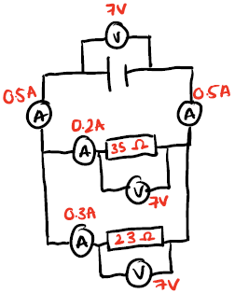

**The potential difference is the same across all components**

**The total resistance is less than the resistance of the least resistor.**

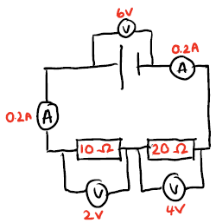

|  |  |
| --- | --- |
| **Key term** | **Definition** |
| Friction | A force resisting the relative motion of surfaces in contact |
| Electrons | Negatively charged sub-atomic particles |
| Static electricity | Transfer of electrons from an object on which they have accumulated |
| Electrical component | Part of an electrical circuit |
| Current | Rate of flow of charge |
| Potential difference | Difference in electrical potential energy between two points in a circuit |
| Resistance | A measure of how difficult it is for current to flow |
| Series | A circuit in which components are connected, one after another in one loop |
| Parallel | A circuit in which components are connected on different loops to each other |
| Ammeter | A component that measures the current through a circuit. |
| Voltmeter | A component that measures the potential difference across a component. |
| Magnetic field | The region around a magnet where another magnet or magnetic material will experience a force |
| Electro-magnet | A magnet produced when an electrical current flows through a coil of wire |



**Grasp it**

**Static Electricity**

1. Describe what happens when you rub a balloon on your jumper

2. Why does the balloon stick to your jumper after what you described in question 1

**Circuit Diagrams**

3. Draw a circuit that contains a battery made of two cells, two resistors with voltmeters to measure the potential difference across each resistor

4. Explain why each of these circuits would not work



**Definitions**

5. What happens to the current when the resistance increases? Explain your answer

6. What happens to the potential difference when the current decreases? Explain your answer

7. Describe and explain the effect on the current in the circuit that adding more lamps would have.

**Series Circuits**

8. If the current on one ammeter in a series circuit displays the reading 2.5A, what would the second ammeter in the circuit display ad why?

9. If the potential difference of a cell in a series circuit was 12 V and the circuit contains two identical resistors, what would the potential difference of each resistor be?

**Parallel Circuits**

10. If the potential difference of a cell in a parallel circuit is 12 V, what would be the potential difference across each of the two lamps in the circuit

**Calculating resistance**

11. state the equation to calculate resistance

12. Calculate the resistance of a 50 V component that has a current of 0.15 A flowing through it.

**Know it**

**Static Electricity**

1. Which sub-atomic particle is positively charged?

2. Which sub-atomic particle is negatively charged?

3. Which sub-atomic particle has no charge?

4. What happens when two oppositely charged objects are brought near to each other?

5. What happens when two same charged objects are brought near to each other?

**Circuit Diagrams**

6. Draw the circuit symbol for a cell

7. Draw the circuit symbol for an ammeter

8. Draw the circuit symbol for a lamp

9. Draw the circuit symbol for a resistor

10. Define the term ‘battery’

**Definitions**

11. Define the term ‘current’

12. Define the term ‘potential difference’

13. Define the term ‘resistance’

14. State the units of current

15. State the units of potential difference

16. State the units of resistance.

**Series Circuits**

17. Draw a series circuit containing a cell and two lamps

18. State the rule for current in a series circuit

19. State the rule for potential difference in a series circuit

20. State the rule for resistance in a series circuit

**Parallel Circuits**

21. Draw a parallel circuit containing a cell and two lamps

22. State the rule for current in a parallel circuit

23. State the rule for potential difference in a parallel circuit

24. State the rule for resistance in a parallel circuit

**Magnetism**

25. Name the 3 magnetic elements

26. What happens when two opposite poles of a magnet are brought near to each other?

**Link it**

**1.** Does an electrical current flow from the positive to the negative terminal of a cell, or, from the negative to the positive terminal? Use your knowledge of electrons to explain your answer.

**2.** Tap water contains impurities that are positively charged. Predict how a balloon, that has been rubbed onto your jumper, will affect a stream of tap water when it is brought near. Give a reason for your answer.

**3.** This central heating system is a model for an electrical circuit. Explain what each part of the central heating system is meant to represent, and why.

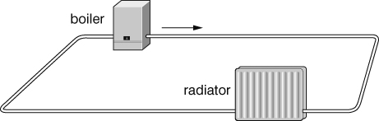

**4.** Plan an investigation into how adding more lamps to a series circuit affects the brightness of the lamps. Include details of your independent, dependent and control variables.

**5.** What are the readings on voltmeters V1 and V2 and on ammeters A1 and A2?

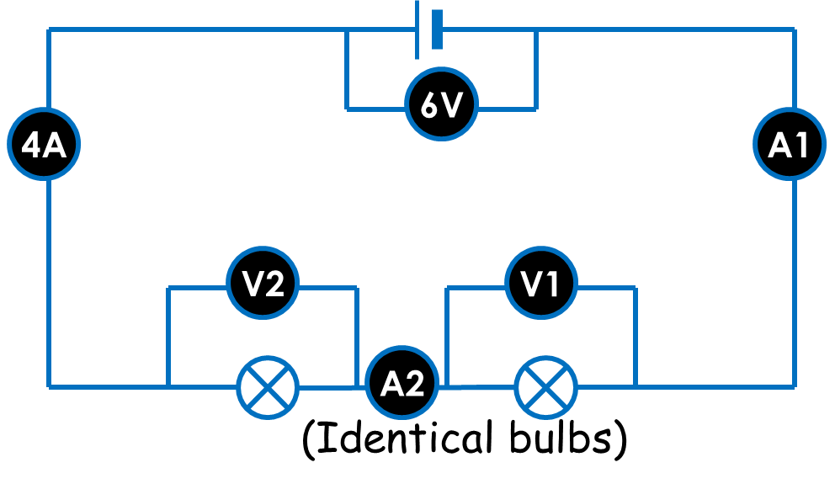

**6.** How can an electromagnet be used to move cars in a scrap yard?