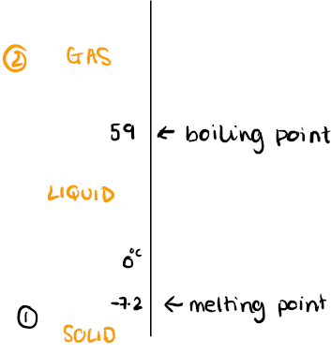

**3. Interpreting Melting and Boiling points**

**7.2 – Particles & Their Behaviour**

**What do I need to be able to do?**

•Draw particle diagrams for the 3 states of matter

•Describe the changes of state between the 3 states of matter

•Describe changes of state as reversible reactions

•Compare the arrangement and movement of particles in the 3 states of matter

•Describe the properties of substances in the 3 states of matter

•Define diffusion and explain factors that increase the rate

•Describe the cause of gas pressure and explain factors that increase it

•Plot and interpret heating/cooling curves

•Use melting and boiling point data to identify the state of a substance at a certain temperature

•Describe the Brownian motion of gases

**2. Heating Curves**

**1. The Particle Model**

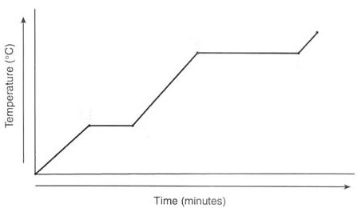

Gas

**Solid**  **Liquid**  **Gas**

liquid

Boiling 🡪

🡨 condensation

melting

evaporation

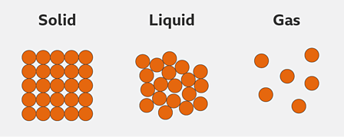

solid

Melting 🡪

🡨 Freezing

condensation

freezing

**Example:** What state is bromine at 25⁰C?

**Mpt** = -7.2⁰C  **Bpt** = 59⁰C

**1.** Draw a number line and plot the melting and boiling points.

**2.** Mark on the states of matter:

**Solid** – below melting point

**Gas** – above boiling point

**Liquid** – between melting and boiling point

**3.** Where does the temperature in the question fit onto the number line?

**Bromine is a liquid at 25⁰C**

|  |  |
| --- | --- |
| **Key** | |
| Horizontal line | •Denotes the melting and boiling points  •Temperature does not increase as the time heating does, as the additional energy is used overcome forces between particle and change state |
| Diagonal line | •As the time spent heating increases, so does the temperature |

more irregular arrangement

less dense

faster movement

|  |  |  |  |
| --- | --- | --- | --- |
| **Property** | **Solid** | **Liquid** | **Gas** |
| Fixed shape | ✔ |  |  |
| Compressible |  |  | ✔ |
| Take shape of container |  | ✔ | ✔ |
| Fill container |  |  | ✔ |

**6. Brownian Motion**

**7. Density**

**5. Diffusion**

**4. Gas Pressure**

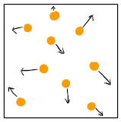

The density of a substance is its mass per unit of volume

***It its calculated using the equation:***

Density (kg/m3) = mass (kg)

Volume (m3)

The **mass** of the substance/object is measured using a scientific balance

The **volume** of a cuboid is calculated using the equation:

**Volume = width x length x height**

Gas particles move very quickly and in random directions. They collide with each other and other particles often, and when they do - this causes them to change direction

**Brownian motion** is the random movement of particles suspended in a **fluid.** It can be visualised using a large visible particle e.g. soot

Occurs in fluids (liquids and gases)

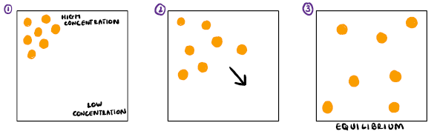

Gas **pressure** is caused by the force of fast-moving gas particles colliding with the walls of their container



**Factors increasing gas pressure:**

• Increase temperature

• Decrease volume

• Increase concentration

**Factors increasing the rate of diffusion:**

• Increase temperature

• Increase the concentration gradient

|  |  |
| --- | --- |
| **Key term** | **Definition** |
| Density | Mass per unit of volume |
| Diffusion | Movement of particles from an area of high concentration to an area of low concentration |
| Compressible | Volume decreases and density increases when pressure is applied |
| Concentration | Amount of substance per unit of volume |
| Equilibrium | Equal concentration in all units of volume |
| Concentration gradient | The difference in concentrations between two areas. |
| Melting | Change of state from a solid to a liquid |
| Freezing | Change of state from a liquid to a solid |
| Condensation | Change of state from a gas to a liquid |
| Evaporation | Change of state from a liquid to a gas |
| Sublimation | Change of state from a solid to a gas |
| Boiling | Rapid change of a liquid into a gas at its boiling point |
| Brownian Motion | Random movement of particles suspended in a fluid |
| Pressure | Force exerted over an area |
| Fluid | Liquid or gas |
| Property | A characteristic of a substance |
| Temperature | A measurement of the internal energy of a substance |

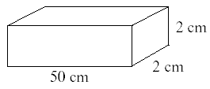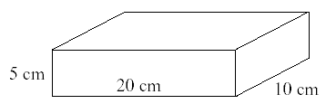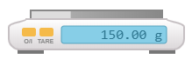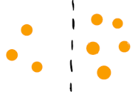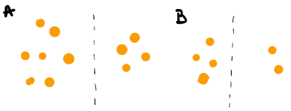

**Link it**

**1.** Sounds travel by vibrating particles, passing vibrations onto neighbouring particles. Using the particle model, suggest why sounds travel faster through solids than gases like air.

**2**. Heat is transferred from one end of a spoon to the other by a process called conduction. Particles are heated and gain more kinetic energy, making them vibrate more. They then pass vibrations onto neighbouring particles.

Using the particle diagrams below to suggest why a wooden spoon would be better to stir soup in a pan on the hob, than a metal spoon.

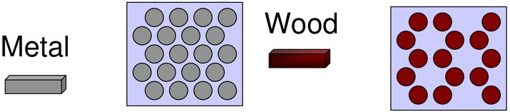

**3.** Calculate the density of this wooden block

***Hint – think carefully about units***

**4.** Calculate the mass of this block

***Hint – think carefully about units***

Density = 0.75 kg/m3

**Grasp it**

**The Particle Model & States of Matter**

1. Compare the density of solids and gases

2. Explain why solids and liquids cannot be compressed

3. Explain why solids have a fixed shape

4. Why do bubbles of gas rise to the surface of fizzy drinks?

**Changes of State**

5. Describe the changes in the arrangement and motion of particles during melting

6. Describe the changes in the arrangement and motion of particles during freezing

7. Why are changes of state examples of a reversible changes? Give examples

**Heating Curves and Melting/Boiling Points**

8. Why does the temperature of the substance not increased during changes of state, despite it still being heated

9. Sodium. Mpt = 98⁰C bpt = 882⁰C

What state is sodium at 56⁰C?

10.Mercury. Mpt = -39⁰C bpt = 357⁰C

What state is mercury at 19⁰C?

**Diffusion**

11. Why does increasing the temperature, increase the rate of diffusion?

12. In which diagram would diffusion happen the fastest? Explain your answer

13. In which direction will diffusion occur? Explain your answer

**Gas Pressure**

14. Explain why increasing the temperature, increases gas pressure.

15. Explain why decreasing the volume, increases gas pressure

16. Explain why increasing the concentration, increases gas pressure

**Know it**

**The Particle Model & States of Matter**

1. How are the particles in a solid arranged?

2. How are the particles in a liquid arranged?

3. Describe the movement of particles in a solid

4. Describe the movement of particles in a gas

5. Define the term ‘density’ and identify the least dense state of matter

**Changes of State**

6. Name the change of state from a liquid to a gas

7. What change of state is involved in freezing?

8. What change of state is shown here?:

 

**Heating Curves and Melting/Boiling Points**

9. How can you identify the melting point on a heating curve?

10. Describe the relationship between points C and D

11. Between which 2 points show the freezing point

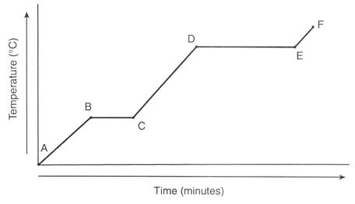

**Diffusion**

12. Define diffusion

13. Give 2 factors that increase the rate of diffusion

14. Draw a diagram to show diffusion occurring

15. Give an example of diffusion occurring

**Gas Pressure**

16. Describe the cause of gas pressure

17. Give 3 factors that increase gas pressure

18. Draw a diagram to show particles in a gas.

19. Alter your diagram in Q18 to show the gas in a smaller volume container. What effect would this have on the pressure?