**Exothermic** - Energy is transferred **from** the reacting molecules **to** the surroundings. Energy is released.

**Temperature of surroundings increases**

e.g. hand warmers, burning fuels

**Endothermic** - Energy is transferred **from** the surroundings **to** the reacting molecules. Energy is absorbed.

**Temperature of surroundings decreases**

e.g. changes of state, cooking

**7.5 – Reactions**

**2. Conservation of Mass**

**What do I need to be able to do?**

•Describe the difference between chemical and physical changes.

•Understand chemical reactions as the rearrangement of atoms

•Understand the conservation of mass in changes of state and chemical reactions.

•Define exothermic and endothermic chemical reactions (qualitative) and classify reactions as such

•Describe and give examples of combustion, thermal decomposition, oxidation and displacement reactions

•Identify the reactants in, and products of, photosynthesis

•Describe the role of catalysts

•Construct a word summary for the reactions involved in photosynthesis, aerobic respiration, combustion, and thermal decomposition reactions

•Apply laws of conservation of mass

**3. Exothermic & Endothermic**

**1. Physical & Chemical Changes**

During chemical reactions, mass is conserved – not lost or gained

Total mass of reactants = total mass of products

The same atoms are present in the reactants and products but just in different arrangements

Therefore we must always balance symbol equations – to show that the reaction obeys the laws of the conservation of mass

**2Mg + O2 🡪 2MgO**

2 atoms of Mg 2 atoms of Mg

2 atoms of O 2 atoms of O

**Physical Changes** are those in which **no new** products are made. This means they are usually easily reversible *e.g. changes of state*

During a **chemical reaction**, bonds are broken in the reactants and atoms are rearranged. Then new bonds form between the atoms forming the **new** products. They are hard to reverse.

**e.g. hydrogen + oxygen 🡪 water**

**2H2 + O2 🡪 2H2O**

reactants products

***Signs that a chemical reaction has occurred:***

• colour changes

• change in temperature

• fizzing or bubbling (due to a gas being released)

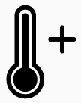

**2g**

**2g**

**18g**

**18g**

**32g**

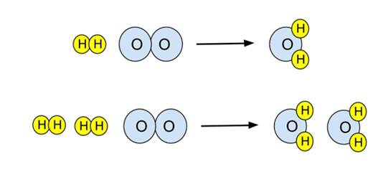

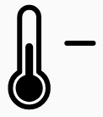

**4. Catalysts**

**5. Photosynthesis & Respiration**

**6. Thermal Decomposition**

**7. Combustion**

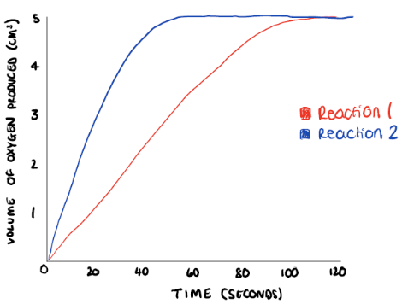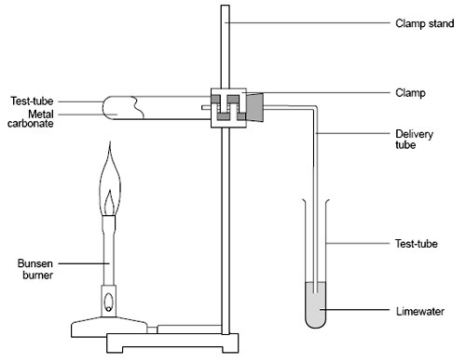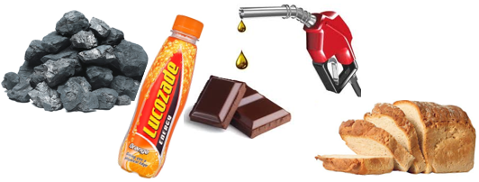

Catalysts are substances added to increase the rate of reaction – they speed up reactions.

*Reaction 2 shows a catalysed reaction compared to reaction 1.* ***The same overall volume of product is made, but in less time.***

***Catalysts are beneficial in industry because:***

• More product is made in a certain time frame (but not in each reaction)

• Are not used up in a reaction

• Work by reducing the energy required to start a reaction

**Photosynthesis** is the chemical reaction in which plants **absorb** and use light energy from the sun to make glucose – a store of energy

**It happens in the leaf cells**

**Carbon dioxide + water 🡪 glucose + oxygen**

6CO2 + 6H2O 🡪 C6H12O6 + 6O2

**Respiration** is the chemical reaction in which energy is released from glucose.

**It happens in the cells of all living organisms**

**glucose + oxygen 🡪 Carbon dioxide + water (+ energy)**

C6H12O6 + 6O2 🡪 6CO2 + 6H2O

**Light energy**

**If the metal carbonate decomposes. Carbon dioxide will turn the limewater cloudy**

When some substances are heated, they do not react with the oxygen in the air, instead they **decompose**

**Thermal decomposition is breaking down substances using into simpler compounds and elements using heat**

e.g. Copper carbonate 🡪 copper oxide + carbon dioxide

CuCO3 🡪 CuO + CO2

**Fuels** are **chemical energy stores** that can be released from reaction with **oxygen.** Energy is released when new bonds are formed in the products of the reaction.

When a fuel is **combusted** (burned) with a plentiful supply of oxygen to release energy, carbon dioxide and water are also produced.

**Fuel + oxygen 🡪 carbon dioxide + water**

e.g. methane + oxygen 🡪 carbon dioxide + water

The carbon dioxide released contributes to global warming.

|  |  |
| --- | --- |
| **Key term** | **Definition** |
| Conservation | Kept the same. |
| Exothermic | Reaction that releases energy to the surroundings |
| Endothermic | Reaction that absorbs energy from the surroundings |
| Reaction | When bonds are broken between atoms, atoms rearranged, and new bonds formed between them |
| Rate | The speed of a reaction. The mass/volume of product produced every second |
| Respiration | Reaction that released energy from the chemical energy store of glucose |
| Photosynthesis | Reaction in which light energy is used by plants to produce glucose |
| Thermal decomposition | Reaction in which compounds are broken down into simpler compounds and elements |
| Combustion | Releasing energy from a chemical store (fuel) by reacting with oxygen |
| Fuel | A chemical store of energy |
| Global warming | The effect of the increasing temperature of the Earth |
| Limewater | A solution of aqueous calcium hydroxide that is used to test for the presence of carbon dioxide |
| Catalyst | A substance added to a reaction to increase the rate |
| Cells | The basic unit of all living organisms |

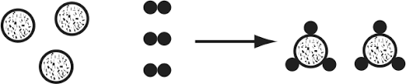

**Link it**

**1.** Explain why changes of state are endothermic processes.

**Hint – revisit 7.2 Particles and their Behaviour**

**2.** Explain why each of the 3 bullet points over leaf for catalysts, make them beneficial for use in industry

**3.** Which of the below sets of data show a catalysed reaction? Explain how you know, using data in your answer.

|  |  |
| --- | --- |
| Time (s) | Mass of product produced (g) |
| 10 | 2 |
| 20 | 4 |
| 30 | 6 |
| 40 | 8 |

|  |  |
| --- | --- |
| Time (s) | Mass of product produced (g) |
| 20 | 2.5 |
| 40 | 5 |
| 60 | 6.5 |
| 80 | 8 |

Plot both sets of data on a graph. Use graph paper, pencil and ruler, or a graph plotting programme or website.

**4.** Construct a balanced symbol equation for the combustion of pentane (C5H12)

**5.** Construct a balanced symbol equation for the thermal decomposition of zinc carbonate (ZnCO3)

**6.** Plan an investigation to determine which metal carbonate; copper carbonate, calcium carbonate and zinc carbonate, has the strongest bonds. Include details of;

•Independent variable

•Dependent variable and how it will be measured

•Control variables and how you will control them

•How you will know which metal carbonate had the strongest bonds

**Know it**

**Physical & Chemical Changes**

1. Give 3 examples of a physical change

2. Give 3 examples of a chemical change

3. Describe what happens during a chemical reaction

4. Give 3 observations that a chemical reaction has occurred

5. define the term ‘observation’

**Conservation of mass**

6. If there are 10g in total of reactants, what mass of products are there in total?

7. Explain your answer to question 6

**Exothermic and Endothermic**

8. Define the term ‘exothermic reaction’

9. Define the term ‘endothermic reaction’

10. How could you tell, in an investigation, if a reaction is exothermic?

11. How could you tell, in an investigation, if a reaction is endothermic?

12. Give 3 examples of exothermic reactions or processes

13. Give 3 examples of endothermic reactions or processes

**Combustion**

14. Define the term ‘fuel’.

15. What gas in the air does the fuel react with, when it is combusted?

16. What two products are always formed when a fuel is combusted in a plentiful supply of air?

**Thermal Decomposition**

17. Define the term ‘thermal decomposition’

18. Describe the test for the presence of carbon dioxide

**Photosynthesis & Respiration**

19. Write a word equation for respiration

20. State where respiration occurs

21. Write a word equation for photosynthesis

22. State where photosynthesis

**Catalysts**

23. Define the term ‘catalyst’

**Grasp it**

**Conservation of mass**

1. If 6g of hydrogen reacts with 28g of nitrogen, what mass of ammonia is produced?

2. Explain how this diagram shows the conservation of mass.

3. Balance this equation

C + O2 🡪 CO

4. Balance this equation

Al + Cl2 🡪 AlCl3

5. Balance this equation

TiCl4 + Mg 🡪 Ti + MgCl2

**Exothermic and Endothermic**

6. Describe how a self-heating can works

7. Why does the temperature of the surroundings decrease in an endothermic reaction?

**Combustion and Thermal Decomposition**

8. Write a word equation for the combustion of propane

9. Write a word equation for the combustion of octane

10. Is a combustion reaction, exothermic or endothermic? Explain how you know.

11. Explain the negative effects of carbon dioxide on the Earth.

12. Explain why combustion can also be considered an oxidation reaction

13. What mass of oxygen does 30g of ethane react with to produce 88g of carbon dioxide and 54g of water

14. Write a word equation for the thermal decomposition of zinc carbonate

15. What mass of carbon dioxide is produced if 100g of calcium carbonate is decomposed into that, and 56g of calcium oxide