**1. Levels of Organisation**

**2. Gas Exchange**

**7.7 – Structure & Function of Body Systems**

**3. Adaptations for Efficient Gas Exchange**

**What do I need to be able to do?**

•Understand the hierarchical organisation of multicellular organisms: from cells to tissues to organs to systems to organisms.

•Describe the structure and functions of the human skeleton

•Describe the function of muscles and give examples of antagonistic muscles.

•Understand biomechanics – the interaction between skeleton and muscles

•Take measurements of force exerted by different muscles

•Describe the structure and functions of the gas exchange system in humans, including adaptations to function.

•Describe the mechanism of breathing to move air in and out of the lungs, using a pressure model to explain the movement of gases

•Take measurements of lung volume

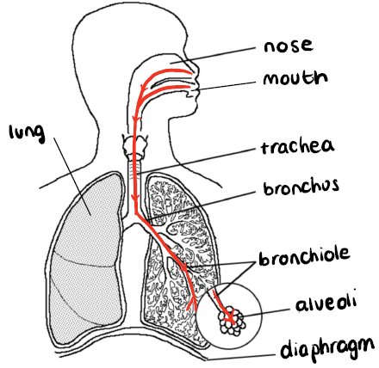

During gas exchange – oxygen and carbon dioxide moves across the walls of the alveoli and capillaries by **diffusion.**

***Revisit 7.2 and 7.6 for a refresher on diffusion***

Gas exchange is important to get oxygen into the bloodstream so it can be delivered to **respiring** cells, and so the products of respiration can be brought to the lungs to be exhaled

***Revisit 7.5 and 7.6 for a refresher on respiration***

To ensure that diffusion of gases into and out of the alveoli is as efficient as possible, the alveoli has the following adaptations:

* Large surface area
* Good blood supply – maintains the concentration gradient
* Thin walls (1 cell thick) – short diffusion distance

This diagram shows the pathway air takes when it is inhaled.

Atoms make up our DNA and other necessary molecules for life e.g. proteins. These molecules then make up organelles, the structures inside cells and so on…

Atoms make up our DNA and other necessary molecules for life e.g. proteins. These molecules then make up organelles, the structures inside cells and so on…

|  |  |  |
| --- | --- | --- |
| Level of Organisation | Definition | Example in humans |
| Organelle | Lots of different organelles work together to make a cell | Nucleus,  mitochondria |
| Cell | The smallest functional biological unit, of which all organisms are composed | Red blood cell, nerve cell, sperm cell |
| Tissue | Lots of the same cell working together to perform a function | Muscle tissue, nerve tissue |
| Organ | Different tissues working together to perform a function | Stomach, brain, heart |
| Organ System | Different organs working together to perform a function | Respiratory system |
| Organism | Different organ systems working together to perform a function | Human, cat, fish, |

This diagram shows the exchange of gases in the alveoli. Oxygen diffuses across the wall of the alveoli and into the capillary (blood vessel). Carbon dioxide moves in the reverse

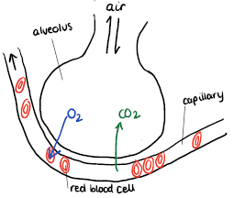

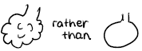

**6. Skeleton**

**6. Respiration**

**5. Joints**

**5. Diffusion**

**4. Muscles**

**4. Unicellular Organisms**

**7. Breathing**

**7. Specialised Cells**

The skeleton can move, at joints, but only by being pulled on by **muscles.**

**Tendons** connect muscles to bones. When a muscle **contract**s, it gets shorter and pulls on the tendon which moves the bone.

Muscles work in pairs to move bones at a joint, called **antagonistic** pairs. When one muscle contracts, the other relaxes and vice versa.

A **joint** is where two bones meet – allowing movement

**Structure of a joint:**

The skeleton is made up of 206 individual bones. It has some very important functions:

* **Support** – the skeleton helps to keep us upright
* **Protection** – the skeleton protects our organs

Cranium – brain

Rib cage – heart and lungs

Vertebrae (spine) – spinal cord

* **Movement** – two bones meet at a joint to allow movement in that area
* **Making blood cells** – red and white blood cells are made in the marrow of bones

|  |  |  |
| --- | --- | --- |
|  | Inhalation | Exhalation |
| Intercostal muscles | Contract | Relax |
| Rib cage | Move up and out | Move down and in |
| Diaphragm | Contract  Flattens (moves down) | Relax  Returns to bell shape (moves up) |
| Lung volume | Increases | Decreases |
| Pressure in lungs | Decreases | Increases |
| Result | Air enters the lungs | Air leaves the lungs |

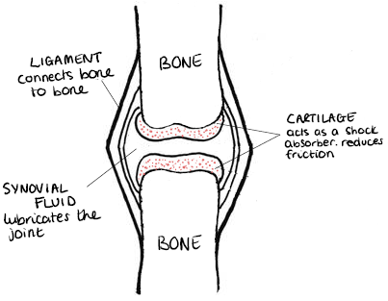

|  |  |  |
| --- | --- | --- |
| Type of Joint | Movement | Example |
| Hinge | Forwards & Backwards | Elbow, knee |
| Ball & Socket | In all directions | Shoulder, hip, neck |
| Fixed | None | Cranium (skull) |

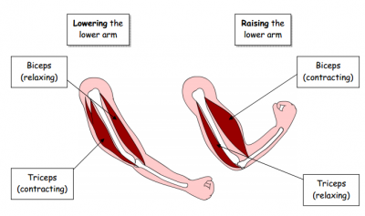

Remember; **breathing** and **respiration** are not the same thing. Breathing is how we get the oxygen we need for respiration – a chemical reaction to release energy - into our blood, so it can be transported to cells.

Substances enter cells from the blood stream, across the cell membrane, via **diffusion**. Substances leave cells by the same method

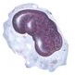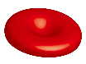

|  |  |
| --- | --- |
| **Key term** | **Definition** |
| Joint | Where two bones meet |
| Antagonistic pair | Pair of muscles acting opposite to each other. When one contracts, the other relaxes and vice versa. |
| Contract | The muscle gets shorter and thicker in the middle |
| Relax | The muscle gets longer and thinner in the middle |
| Organelle | Structures inside a cell |
| Respiration | A chemical reaction in which energy is released from glucose, a chemical energy store |
| Aerobic | Involving oxygen |
| Anaerobic | A lack/absence of oxygen |
| Diffusion | Movement of particles from an area of high concentration to an area of low concentration |
| Concentration gradient | A difference in concentrations. An area that is at high concentration to the other |
| Inhalation | Breathing in |
| Exhalation | Breathing out |
| Lung volume | Space inside the lung. Capacity to hold air |
| Pressure | Force applied over a unit of area |
| Tendon | Connects muscle to bone |
| Ligament | Connects bone to bone |

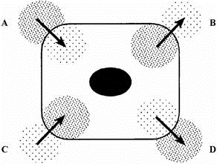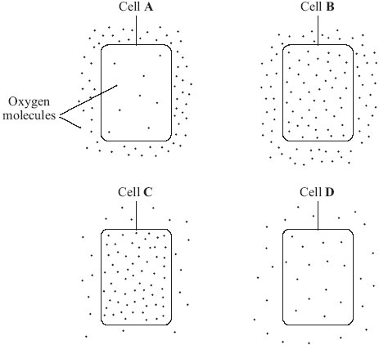

**Link it**

**1.** Muscle cells require lots of energy to contract. Which organelle will they have lots of?

**2.** Write a paragraph explaining the link between the following; bone marrow, gas exchange, breathing, respiration, diffusion.

**3.** Write a balanced symbol equation for aerobic respiration. Glucose is C6H12O6.

**4**. When muscles contract very quickly, you get a cramp. Explain why.

**5**. Explain the difference between breathing and respiration

**6**. Into which cell, will oxygen diffuse the fastest? Explain your answer.

**8.** This cell is respiring aerobically. Which letter represents the movement of;

**a.** oxygen

molecules

**b.** carbon

dioxide

molecules

Explain your answers.

**Grasp it**

**Gas Exchange**

1. Gases move across the walls of the alveoli and capillaries by diffusion. Explain how oxygen diffuses into the blood stream from the alveoli

2. Oxygen is transported to respiring cells. Write the word equation for aerobic respiration

3. What happens to the waste products of respiration?

4. Describe the adaptations of the alveoli for efficient diffusion of gases during gas exchange.

**Breathing**

5. A students says, ‘we breathe in oxygen and breathe out carbon dioxide’. Explain why this statement is not entirely correct.

6. Why does air leave the lungs during exhalation?

**Diffusion**

7. Draw a diagram to represent the concentrations of oxygen in the alveoli and the blood stream and explain the direction of travel of the oxygen molecules.

8. The alveoli have a good blood supply to maintain a concentration gradient. Explain what this means and suggest what would happen if it was not maintained.

**Skeleton & Joints**

9. People with bone marrow cancer produce less red and white blood cells than healthy people. Explain the effect that this would have.

10. People with arthritis have less cartilage coating the ends of their bones. Explain why this causes pain for the sufferer.

**Muscles**

11. Describe the action of the antagonistic muscle pairs involved in moving your upper leg whilst walking.

12. Why are the heart and stomach mainly muscle tissue?

**Know it**

**Levels of Organisation**

1. Put the following in order starting from the smallest; organ, organelle, tissue, cell, organism.

2. Put the following in order, starting from the smallest; mitochondria, nerve cell, human, spinal cord, nervous system

3. Define the term ‘tissue’

4. Define the term ‘organ’

5. Name 3 organ systems in the body.

**Gas Exchange**

6. Put the following parts of the respiratory system in order, starting from where air first enters when inhaling; bronchus, alveoli, trachea, mouth, bronchiole

7. In which part of the lungs does gas exchange occur?

8. Which gases, and in which direction, are exchanged?

**Breathing**

9. What happens to the intercostal muscles and diaphragm when inhaling?

10. What happens to the rib cage when breathing out?

11. Is the lung volume bigger on inhalation or exhalation?

**Skeleton & Joints**

12. Describe 4 functions of the skeleton

13. What is the function of ligaments?

14. What is the function of the cartilage?

15. What is the function of the synovial fluid?

16. Which type of joint allows no movement?

17. which type of joint is in your ankle?

**Muscles**

18. Describe what is meant by ‘antagonistic muscle pairs’

19. How does a muscle move a bone at a joint?

20. What happens when a muscle contracts?