Protecting your identity online
- Don’t include personal data such as your date of birth, address, phone number in your profile
- Don’t post photos taken at home – and if you do, make sure location sharing is OFF
- Be aware of your privacy settings
Rules for creating secure passwords
- Don’t use common names, words or dates such as birthdays
- Use different passwords for different sites
- Use a mix of characters - capital letters, lowercase letters, numbers and symbols
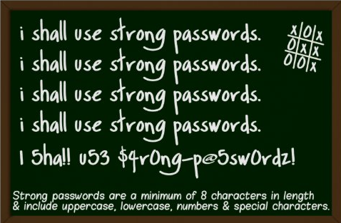

Key Terms | What it means?
Cybercrime | A crime committed using a personal computer, laptop, smartphone and the internet (network).
Hacking | Illegally accessing or modifying computer files without permission.
Malware | Malicious software, a small program which enters a computer or network through a downloaded file or vulnerability in a network.
Virus | A type of malware which replicates and installs itself on your computer without your consent.
Spyware | Spyware is a type of virus that is specifically designed to steal information about your activity on your computer.
GDPR | General Data Protection Regulation – the law which sets out how your personal data is protected by those who hold it.
Intellectual property (IP) | Creations of the mind for example art, music, software, books or films.
Copyright | Protection that owners of intellectual property have to prevent their work being illegally copied.
Plagiarism | Copying someone else’s work and presenting it as your own.

Types of E-mail/Messaging Scams | What it means?
Phishing | An email which looks like it’s from your bank or other organisation. It sends you to a fake website which tricks you into handing over sensitive or personal information.
Trojan | An email which offers something tempting to look at such as a funny video. When you click on the link, it installs a virus on your computer.
Ransomware | A type of malicious software that is planted on your computer system or smartphone and is designed to block your access until a sum of money is paid.
Virus generated | An email which appears to come from a friend which may include a recommendation and a link to find out more.
What is phishing?
- Phishing is when you receive an email or text message which looks like it’s from your bank or other organisation and it tries to trick you into handing over sensitive or personal information e.g. bank details or PayPal details.

What is the difference between copyright theft and plagiarism?
- Copyright theft is when you use or steal somebody else’s intellectual property without their permission. Plagiarism is when you pass off somebody else’s work as your own.

How to change your privacy settings on social media
  - Be aware of your privacy settings and know how to change them.
- See Childline digital footprint privacy settings website for more information on how to change your privacy settings:
https://www.childline.org.uk/info-advice/bullying-abuse-safety/online-mobile-safety/taking-care-your-digital-footprint/

